**AN1114**

**Switch Mode Power Supply (SMPS) Topologies (Part I)**

*Author: Mohammad Kamil*

*Microchip Technology Inc.*

### EQUATION 1: SHUNT-CONTROLLED

**REGULATOR POWER LOSS**

2

# INTRODUCTION

*PLOSS* = *VOUT* ⋅ *IS* + (*IOUT* + *IS* )

* *RS*

The industry drive toward smaller, lighter and more efficient electronics has led to the development of the Switch Mode Power Supply (SMPS). There are several topologies commonly used to implement SMPS.

This application note, which is the first of a two-part series, explains the basics of different SMPS topologies. Applications of different topologies and

their pros and cons are also discussed in detail. This

However, if we control the output voltage VOUT by varying RS and keeping IS zero, the ideal power loss inside the converter can be calculated as shown in Equation 2.

### EQUATION 2: SERIES-CONTROLLED

**REGULATOR POWER LOSS**

2 *RS*

= ⋅ ------------------

2

application note will guide the user to select an

appropriate topology for a given application, while providing useful information regarding selection of

*PLOSS VIN*

--------

(*RS* + *RL* )

electrical and electronic components for a given SMPS design.

# WHY SMPS?

The main idea behind a switch mode power supply can easily be understood from the conceptual explanation of a DC-to-DC converter, as shown in Figure 1. The load, RL, needs to be supplied with a constant voltage, VOUT, which is derived from a primary voltage source, VIN. As shown in Figure 1, the output voltage VOUT can be regulated by varying the series resistor (RS) or the shunt current (IS).

When VOUT is controlled by varying IS and keeping RS constant, power loss inside the converter occurs. This type of converter is known as shunt-controlled regulator. The power loss inside the converter is given by Equation 1. Please note that the power loss cannot be eliminated even if IS becomes zero.

### FIGURE 1: DC-DC CONVERTER

RS IOUT



RL

This type of converter is known as a series-controlled

regulator. The ideal power loss in this converter depends on the value of the series resistance, RS, which is required to control the output voltage, VOUT, and the load current, IOUT. If the value of RS is either zero or infinite, the ideal power loss inside the converter should be zero. This feature of a series-controlled regulator becomes the seed idea of SMPS, where the conversion loss can be minimized, which results in maximized efficiency.

In SMPS, the series element, RS, is replaced by a semiconductor switch, which offers very low resistance at the ON state (minimizing conduction loss), and very high resistance at the OFF state (blocking the conduction). A low-pass filter using non-dissipative passive components such as inductors and capacitors is placed after the semiconductor switch, to provide constant DC output voltage.

The semiconductor switches used to implement switch mode power supplies are continuously switched on and off at high frequencies (50 kHz to several MHz), to transfer electrical energy from the input to the output through the passive components. The output voltage is controlled by varying the duty cycle, frequency or phase of the semiconductor devices’ transition periods. As the size of the passive components is inversely proportional to the switching frequency, a high

VIN

IS VOUT

switching frequency results in smaller sizes for magnetics and capacitors.

While the high frequency switching offers the designer a huge advantage for increasing the power density, it adds power losses inside the converter and introduces additional electrical noise.

# SELECTION OF SMPS TOPOLOGIES

There are several topologies commonly used to implement SMPS. Any topology can be made to work for any specification; however, each topology has its own unique features, which make it best suited for a certain application. To select the best topology for a given specification, it is essential to know the basic operation, advantages, drawbacks, complexity and the area of usage of a particular topology. The following factors help while selecting an appropriate topology:

1. Is the output voltage higher or lower than the whole range of the input voltage?
2. How many outputs are required?
3. Is input to output dielectric isolation required?
4. Is the input/output voltage very high?
5. Is the input/output current very high?
6. What is the maximum voltage applied across the transformer primary and what is the maximum duty cycle?

Factor (a) determines whether the power supply topology should be buck, boost or buck-boost type. Factors (b) and (c) determine whether or not the power supply topology should have a transformer. Reliability of the power supply depends on the selection of a proper topology on the basis of factors (d), (e) and (f).

## Buck Converter

A buck converter, as its name implies, can only produce lower average output voltage than the input voltage. The basic schematic with the switching waveforms of a buck converter is shown in Figure 2.

In a buck converter, a switch (Q1) is placed in series with the input voltage source VIN. The input source VIN feeds the output through the switch and a low-pass filter, implemented with an inductor and a capacitor.

In a steady state of operation, when the switch is ON for a period of TON, the input provides energy to the output as well as to the inductor (L). During the TON period, the inductor current flows through the switch and the difference of voltages between VIN and VOUT is applied to the inductor in the forward direction, as shown in Figure 2 (C). Therefore, the inductor current IL rises linearly from its present value IL1 to IL2, as shown in Figure 2 (E).

During the TOFF period, when the switch is OFF, the inductor current continues to flow in the same direction, as the stored energy within the inductor continues to supply the load current. The diode D1 completes the inductor current path during the Q1 OFF period (TOFF); thus, it is called a freewheeling diode. During this TOFF period, the output voltage VOUT is applied across the inductor in the reverse direction, as shown in Figure 2 (C). Therefore, the inductor current decreases from its present value IL2 to IL1, as shown in Figure 2 (E).

### FIGURE 2: BUCK CONVERTER

IIN

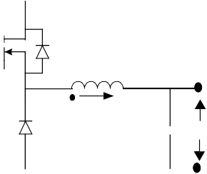

**(A)**

Q1 VIN

D1

L

+ IL -

IOUT VOUT

**(B)**

Q1GATE

t

**(C)**

VL VIN - VOUT

t

-VOUT

(VIN - VOUT)/L

**(D)**

IIN

t

**(E)**

IL2 IL

I

-VOUT/L

L1

t

**(A)** = Buck converter

**(B)** = Gate pulse of MOSFET Q1

**(C)** = Voltage across the Inductor L

**(D)** = Input current IIN

**(E)** = Inductor current IL

#### CONTINUOUS CONDUCTION MODE

The inductor current is continuous and never reaches zero during one switching period (TS); therefore, this mode of operation is known as Continuous Conduction mode. In Continuous Conduction mode, the relation between the output and input voltage is given by Equation 3, where D is known as the duty cycle, which is given by Equation 4.

### EQUATION 3: BUCK CONVERTER VOUT/VIN

**RELATIONSHIP**

*VOUT* = *D* ⋅ *VIN*

### EQUATION 4: DUTY CYCLE

*T*

*ON*

*D* = ----------

*TS*

where:

*TON* = ON Period

*TS* = Switching Period

If the output to input voltage ratio is less than 0.1, it is always advisable to go for a two-stage buck converter, which means to step down the voltage in two buck operations. Although the buck converter can be either continuous or discontinuous, its input current is always discontinuous, as shown in Figure 2 (D). This results in a larger electromagnetic interference (EMI) filter than the other topologies.

#### CURRENT MODE CONTROL

While designing a buck converter, there is always a trade-off between the inductor and the capacitor size selection.

A larger inductor value means numerous turns to the magnetic core, but less ripple current (<10% of full load current) is seen by the output capacitor; therefore, the loss in the inductor increases. Also, less ripple current makes current mode control almost impossible to implement (refer to **“Me****thod of Contro****l”** for details on current mode control techniques). Therefore, poor load transient response can be observed in the converter.

A smaller inductor value increases ripple current. This makes implementation of current mode control easier, and as a result, the load transient response of the converter improves. However, high ripple current needs a low Equivalent Series Resistor (ESR) output capacitor to meet the peak-to-peak output voltage ripple requirement. Generally, to implement the current mode control, the ripple current at the inductor should be at least 30% of the full load current.

#### FEED-FORWARD CONTROL

In a buck converter, the effect of input voltage variation on the output voltage can be minimized by implementing input voltage feed-forward control. It is easy to implement feed-forward control when using a digital controller with input voltage sense, compared to using an analog control method. In the feed-forward control method, the digital controller starts taking the appropriate adaptive action as soon as any change is detected in the input voltage, before the change in input can actually affect the output parameters.

#### SYNCHRONOUS BUCK CONVERTER

When the output current requirement is high, the excessive power loss inside the freewheeling diode D1, limits the minimum output voltage that can be achieved. To reduce the loss at high current and to achieve lower output voltage, the freewheeling diode is replaced by a MOSFET with a very low ON state resistance RDSON. This MOSFET is turned on and off synchronously with the buck MOSFET. Therefore, this topology is known as a synchronous buck converter. A gate drive signal, which is the complement of the buck switch gate drive signal, is required for this synchronous MOSFET.

A MOSFET can conduct in either direction; which means the synchronous MOSFET should be turned off immediately if the current in the inductor reaches zero because of a light load. Otherwise, the direction of the inductor current will reverse (after reaching zero) because of the output LC resonance. In such a scenario, the synchronous MOSFET acts as a load to the output capacitor, and dissipates energy in the RDSON (ON state resistance) of the MOSFET, resulting in an increase in power loss during discontinuous mode

of operation (inductor current reaches zero in one switching cycle). This may happen if the buck converter inductor is designed for a medium load, but needs to operate at no load and/or a light load. In this case, the output voltage may fall below the regulation limit, if the synchronous MOSFET is not switched off immediately after the inductor reaches zero.

#### MULTIPHASE SYNCHRONOUS BUCK CONVERTER

It is almost impractical to design a single synchronous buck converter to deliver more than 35 amps load current at a low output voltage. If the load current requirement is more than 35-40 amps, more than one converter is connected in parallel to deliver the load.

To optimize the input and output capacitors, all the parallel converters operate on the same time base and each converter starts switching after a fixed time/phase from the previous one. This type of converter is called a multiphase synchronous buck converter. Figure 3 shows the multiphase synchronous buck converter with a gate pulse timing relation of each leg and the input current drawn by the converter. The fixed time/phase is given by *Time period/n* or 300*/n*, where “*n*” is the number of the converter connected in parallel.

The design of input and output capacitors is based on the switching frequency of each converter multiplied by the number of parallel converters. The ripple current seen by the output capacitor reduces by “n” times. As shown in Figure 3 (E), the input current drawn by a multiphase synchronous buck converter is continuous with less ripple current as compared to a single converter shown in Figure 2 (D). Therefore, a smaller input capacitor meets the design requirement in case of a multiphase synchronous buck converter.

### FIGURE 3: MULTIPHASE SYNCHRONOUS BUCK CONVERTER

+

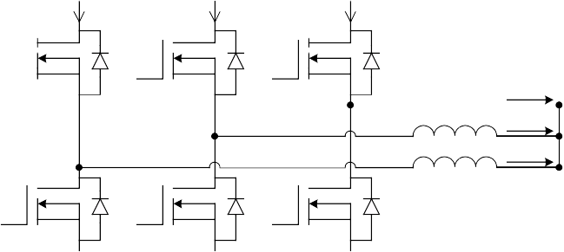

IQ1

IQ3

IQ5

**(A)**

CIN

-

Q1 Q3 Q5 VIN

Q2 Q4 Q6

L3 IL3

L2 IL2

L1 IL1

VOUT

CO

IL1

**(B)**

Q1PWM

t

**(C)**

Q3PWM

IL2

t

IL3

**(D)**

Q5PWM

t

IQ5 + IQ1

IQ1 + IQ3 IQ3 + IQ5 IQ5 + IQ1

**(E)**

IIN

IQ1 IQ3 IQ5

t

**(A)** = Multiphase Synchronous Buck converter

**(B)** = Gate pulse of Q1, inductor current IL1

**(C)** = Gate pulse of Q3, Inductor current IL2

**(D)** = Gate pulse of Q5, Inductor current IL3

**(E)** = Input current IIN

## Boost Converter

A boost converter, as its name implies, can only produce a higher output average voltage than the input voltage. The basic schematic with the switching waveform of a boost converter is shown in Figure 4.

In a boost converter, an inductor (L) is placed in series with the input voltage source VIN. The input source feeds the output through the inductor and the diode D1. In the steady state of operation, when the switch Q1 is ON for a period of TON, the input provides energy to the inductor.

During the TON period, inductor current (IL) flows through the switch and the input voltage VIN is applied to the inductor in the forward direction, as shown in Figure 4 (C). Therefore, the inductor current rises linearly from its present value IL1 to IL2, as shown in Figure 4 (D). During this TON period, the output load current IOUT is supplied from the output capacitor CO. The output capacitor value should be large enough to supply the load current for the time period TON with the minimum specified droop in the output voltage.

### FIGURE 4: BOOST CONVERTER

During the TOFF period when the switch is OFF, the inductor current continues to flow in the same direction as the stored energy with the inductor, and the input source VIN supplies energy to the load. The diode D1 completes the inductor current path through the output capacitor during the Q1 OFF period (TOFF). During this TOFF period, the inductor current flows through the diode and the difference of voltages between VIN and VOUT is applied to the inductor in the reverse direction, as shown in Figure 4 (C). Therefore, the inductor current decreases from the present value IL2 to IL1, as shown in Figure 4 (D).

#### CONTINUOUS CONDUCTION MODE

As shown in Figure 4 (D), the inductor current is continuous and never reaches zero during one switching cycle (TS); therefore, this method is known as Continuous Conduction mode, which is the relation between output and input voltage, as shown in Equation 5.

IL

+ + -

V

L

D1

ID1

IOUT

+

**(A)**

VIN Q1

CO VOUT

- -

**(B)**

Q1PWM

t

**(C)** VL

VIN

t VOUT - VIN

**(D)**

**(E)**

IL2 IL1

VDS

IQ1 ID1

t

VOUT

t

**(A)** = Boost converter

**(B)** = Gate pulse of MOSFET Q1

**(C)** = Voltage across the inductor L

**(D)** = Current through the MOSFET Q1 and diode D1

**(E)** = Voltage across the MOSFET Q1

### EQUATION 5: VOUT/VIN RELATIONSHIP

*V* = *VIN* -

*OUT* ----------------

(1 – *D*)

The root mean square (RMS) ripple current in the output capacitor is given by Equation 6. It is calculated by considering the waveform shown in Figure 4 (D). During the TOFF period, the pulsating current ID1, flows into the output capacitor and the constant load current (IOUT) flows out of the output capacitor.

### EQUATION 6: CAPACITOR RIPPLE RMS CURRENT

2

2

unity. In addition, input current should follow the input sinusoidal voltage waveform to meet the displacement factor so that it is close to unity.

## Forward Converter

A forward converter is a transformer-isolated converter based on the basic buck converter topology. The basic schematic and switching waveforms are shown in Figure 6.

In a forward converter, a switch (Q1) is connected in series with the transformer (T1) primary. The switch creates a pulsating voltage at the transformer primary winding. The transformer is used to step down the primary voltage, and provide isolation between the

where:

*IRIPPLERMS* =

(*ID*1 )

– (*IOUT* )

input voltage source VIN and the output voltage VOUT. In the steady state of operation, when the switch is ON for a period of TON, the dot end of the winding becomes

*ID*1*RMS* = RMS value of *ID*1

*IRIPPLERMS* = Ripple RMS current of capacitor

*IOUT* = Output DC current

Based on Equation 5, the VOUT/VIN ratio can be very large when the duty cycle approaches unity, which is ideal. However, unlike the ideal characteristic, VOUT/VIN declines as the duty ratio approaches unity, as shown in Figure 5. Because of very poor utilization of the switch, parasitic elements occur in the components and losses associated with the inductor capacitor and semiconductors.

### FIGURE 5: VOUT/VIN AND DUTY CYCLE

**IN BOOST CONVERTER**

VOUT/VIN 7

positive with respect to the non-dot end. Therefore, the diode D1 becomes forward-biased and the diodes D2 and D3 become reverse-biased.

As the input voltage VIN is applied across the transformer primary, the magnetizing current IM increases linearly from its initial zero value to a final value with a slope of VIN/LM, where LM is the magnetizing inductance of the primary winding, as shown in Figure 6(D). The total current that flows through the primary winding is this magnetizing current plus the inductor current (IL) reflected on the primary side. This total current flows through the MOSFET during the TON period. The voltage across the diode D2 is equal to the input voltage multiplied by the transformer turns ratio (NS/NP). In the case of a forward converter, the voltage applied across the inductor L in the forward direction during the TON period, is given by Equation 7, neglecting the transformer losses and the

6 Ideal

5

4

3

Practical

diode forward voltage drop.

### EQUATION 7: FORWARD VOLTAGE

**ACROSS INDUCTOR**

2

*V*

*L*

= *V*

*IN*

1

*N*

⋅ ------ – *V*

*S*

*NP*

*OUT*

Δ*IL*

= *L* ⋅ --------

Δ*t*

0.25 0.5 0.75 1

Duty Cycle = D

#### POWER FACTOR CORRECTION

When the boost converter operates in Continuous Conduction mode, the current drawn from the input voltage source is always continuous and smooth, as shown in Figure 4 (D). This feature makes the boost converter an ideal choice for the Power Factor Correction (PFC) application. Power Factor (PF) is given by the product of the Total Current Harmonics Distortion Factor (THD) and the Displacement Factor (DF). Therefore, in PFC, the input current drawn by the converter should be continuous and smooth enough to meet the THD of the input current so that it is close to

#### DISSIPATING ENERGY

At the end of the ON period, when the switch is turned OFF, there is no current path to dissipate the stored energy in the magnetic core. There are many ways to dissipate this energy. One such method is shown in Figure 6. In this method, the flux stored inside the magnetic core induces a negative voltage at the dot end of the NR winding, which forward biases the diode D3 and resets the magnetizing energy stored in the core. Therefore, the NR winding is called the reset winding. Resetting the magnetizing current during the OFF period is important to avoid saturation.

During the TOFF period when the switch is OFF, the inductor current (IL) continues to flow in the same direction, while the stored energy within the inductor continues to supply the load current IOUT.

### FIGURE 6: FORWARD CONVERTER

I3

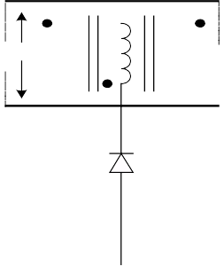

+

T1 D1

+

IL

+ VL - +

VP NP NS D2

VOUT

**(A)**

1. Q1PWM

VIN

-

- NR -

ISW D

D3 Q1

G

S

t

1. VP

VIN

t (1+NP/NR) • VIN

IM IM

**(D)**

IIN

IP IM IM

t

I

P

I3 I3

TON TM

TOFF TS

**(E)**

**(F)**

VDS

IL

(1+NP/NR) • VIN (1+NP/NR) • VIN

VIN VIN

IL IOUT

t

ΔIL

t

**(A)** = Forward Converter power circuit diagram.

**(B)** = Gate pulse of MOSFET Q1

**(C)** = Voltage across the transformer primary winding NP

**(D)** = Current through NP and NR

**(E)** = Voltage across the MOSFET Q1

**(F)** = Output Inductor current IL

The diode D2, called a freewheeling diode, completes the inductor current path during the Q1 off period (TOFF). During this TOFF period, the output voltage VOUT

### EQUATION 10: MAXIMUM DUTY CYCLE AND VDS

= ⎛ *NR*⎞ ⋅ *D*

is applied across the inductor in the reverse direction.

In a continuous conduction mode of operation, the rela-

(1 – *DMAX* )

⎝ ------

*P*

*MAX*

*N* ⎠

tion between the output voltage and input voltage is

*N*

*D* = 1--------------

given by Equation 8, where D is the duty cycle.

### EQUATION 8: FORWARD CONVERTER

*MAX*

⎛ ------

⎝

1

*N* ⎠⎠

+ ⎛ *R*⎞⎞

⎝

*P*

⎛ *NP*⎞

= + ⋅

------

⎛ *NS*

**VOUT/VIN RELATIONSHIP**

⎞

*VDS VIN VIN*

⎝ *NR*⎠

⎝*VIN*

⋅ ------ – *V NP*

*OUT*⎠ ⋅ *TON*

= *VOUT*

* *TOFF*

The maximum value of TM/TS to completely demagnetize before the next cycle begins is equal to

*VOUT* = *VIN*

* ⎛ *NS*-⎞ ⋅ *D*

*NP*

⎝ ----- ⎠

(1-D), so the maximum duty ratio for the forward converter is given by Equation 10.

From Equation 10, it is understood that when the

#### CONTROLLING MAGNETIZATION

When the switch is turned OFF, the diode D1 becomes reverse-biased, and IM cannot flow in the secondary side. Therefore, the magnetizing current is taken away by the reset winding of the transformer, as shown in Figure 6(A and D).

The reflected magnetizing current I3 flows through the reset winding NR and the diode D3 into the input supply. During the interval TM when I3 is flowing, the voltage across the transformer primary as well as LM is given by Equation 9.

### EQUATION 9: REFLECTED VOLTAGE AT

number of primary winding turns, NP, is equal to the number of the reset winding turns, NR, the switch can have a maximum 50% duty cycle and the blocking voltage of the switch will be equal to twice the input voltage. The practical limit of maximum duty cycle should be 45%, and maximum blocking voltage seen by the switch will be more than twice the input voltage due to the nonlinearity of components and the leakage inductance of the transformer.

### EQUATION 11: MAGNETIZING STORED

**ENERGY IN FLYBACK TRANSFORMER**

**PRIMARY**

⎛ *NP*⎞

*E* = 1-- ⋅ (*I* )2

*P* 2 *PK*

* *LM*

------

⎝

⎠

* *VIN*

(*VIN*

* *TON* )

*NR*

Time taken by the transformer to complete the demagnetization can be obtained by recognizing that the time integral of voltage across the LM must be zero

where:

*EP* = Joules

*IPK* = Amps

*IPK* = ----------------------------

*LM*

over one time period. The maximum value of TM, as

shown in Figure 6, is the time it takes the transformer to completely demagnetize before the next cycle begins and is equal to TOFF. Therefore, the maximum duty cycle and the maximum drain-to-source blocking voltage (VDS) seen by the switch (Q1) in a forward converter having number of primary and number of reset winding turns as NP and NR, is given by Equation 10.

*LM* = Henries

If NR is chosen to be less than NP, the maximum duty cycle DMAX can be more than 50%; however, the maximum blocking voltage stress of the switch becomes more than 2 • VIN the value of DMAX and VDS, as shown in Equation 10. If NR is chosen to be larger than NP, DMAX will be less than 50%, but the maximum blocking voltage stress of the switch is now less than 2• VIN, the value of DMAX and VDS, as shown in

Equation 10.

Since large voltage isolation is not required between the reset and the primary windings, these two windings can be wound bifilar to minimize leakage inductance. The reset winding carries only the magnetizing current, which means it requires a smaller size of wire as compared to the primary winding.

To demagnetize the transformer core, a Zener diode or RC snubber circuit can also be used across the transformer instead of the transformer reset winding.

The incomplete utilization of the magnetics, the maximum duty cycle limit and the high voltage stress of the switch, make a forward converter feasible for the output power (up to 150 watts) of an off-line low-cost power supply. Its non-pulsating output inductor current makes the forward converter well suited for the application involving a very high load current (>15A). The presence of the output inductor limits the use of a forward converter in a high output voltage (>30V) application, which requires a bulky inductor to oppose the high output voltage.

#### INCREASING EFFICIENCY

The efficiency of a forward converter is low compared to other topologies with the same output power, due to the presence of four major loss elements: the switch, transformer, output diode rectifiers and output inductor.

To increase efficiency, a synchronous MOSFET can be used in place of the output diode rectifier. The MOSFET can be self-driven through the extra or the same windings in the transformer secondary, as shown in Figure 7.

### FIGURE 7: SYNCHRONOUS RECTIFIER

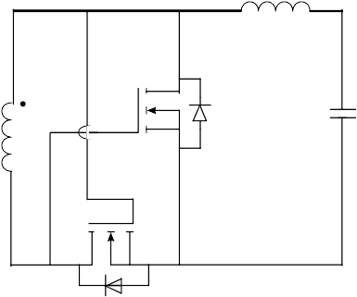

Q1 G

|  |  |  |  |
| --- | --- | --- | --- |
| D | | | rest of the switching period. The secondary side |
| operation of the two-switch forward converter is the |
| same as the operation of the forward converter |
|  |  |  | explained earlier.  APPLICATION CONSIDERATIONS |

## Two-Switch Forward Converter

The maximum voltage stress of the switch in a forward converter can be limited to a value equal to the input voltage, by placing one more switch (Q2) in series with the transformer primary winding, as shown in Figure 8. The resulting converter is called a two-switch forward converter. The basic schematic and switching waveforms of the two-switch forward converter are shown in Figure 8.

The switches Q1 and Q2 are controlled by the same gate drive signal, as shown in Figure 8 (B and C). In the steady state of operation, when the switches Q1 and Q2 are ON for a TON period, the input voltage VIN is applied to the transformer primary. During the TON period, the magnetizing current plus the reflected output inductor current flows through the transformer primary and the switches Q1 and Q2.

At the end of the ON period, when the switches are turned OFF, the flux stored inside the magnetic core induces a voltage in the reverse direction to the transformer primary winding, which forward-biases the diodes D1 and D2, and provides a path to the magnetizing current to reset the core. The voltage VIN is applied across the transformer primary winding in the reverse direction, as shown in Figure 8 (D). If there is no leakage inductance in the transformer T1, the voltage across NP would be equal to VIN, and the maximum blocking voltage across the switch is VIN. When the magnetizing current reaches zero, diodes D1 and D2 become reverse-biased and remain zero for the

S

Q2 G

D S

Improving the load transient response and implementing current mode control requires reducing the output inductor value and the use of a better output capacitor to meet the output voltage ripple requirement, as discussed in the **“Bu****ck Conver****ter”** section. A multiple output, forward converter coupled inductor is used to get better cross-load regulation requirements.

Reduction in the blocking voltage of the switch allows the designer to select a better low-voltage MOSFET for the design. Therefore, the two-switch forward converter can be used up to the output power level of 350 watts. If peak current is greater than 350 watts, losses across the MOSFET become impractical to handle, and incomplete utilization of magnetic makes the transformer bulky (see Figure 9). Therefore, the two-switch forward converter is best suited for applications with an output power level range of 150 to 350 watts.

### FIGURE 8: TWO-SWITCH FORWARD CONVERTER

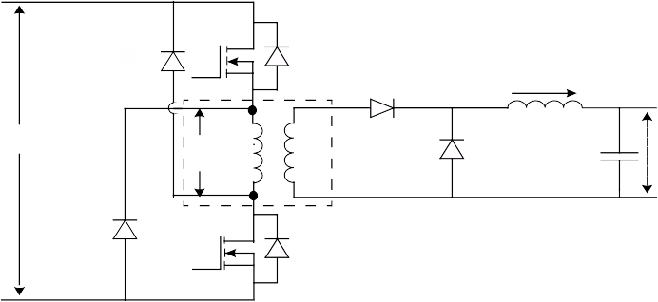

+

D1 Q2 D

D

3

IL

+ VL - +

**(A)**

VIN

D2

VP NP NS D4

VOUT

-

Q1 D

-

**(B)**

**(C)**

**(D)**

Q1PWM

Q2PWM

VP VIN

IN

TS

TOFF

t

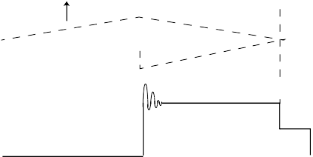

t

t VIN

**(E)** VP IP

**(F)**

t

VIN

t

**(A)** = Two-switch forward converter power circuit

**(B)** = Gate pulse for MOSFET Q1

**(C)** = Gate pulse for MOSFET Q2

**(D)** = Voltage across the primary winding NP

**(E)** = Current through the primary winding NP

**(F)** = Voltage across the MOSFET Q1 and Q2

.

### FIGURE 9: TRANSFORMER BH CURVE

**OF SINGLE SWITCH CONVERTER**

**EQUATION 12: FLYBACK CONVERTER**

**VOUT/VIN RELATIONSHIP**

*VOUT*

⎛ *NS*⎞ ⎛ *D* ⎞

------------- = ⎝ ------

⋅ ⎝ -----------------

B

where:

*VIN*

*NP*⎠

(1 – *D*)⎠

BSAT

*D* = the duty cycle of the flyback switch

ΔB

H

## Flyback Converter (FBT)

A flyback converter (FBT) is a transformer-isolated converter based on the basic buck boost topology. The basic schematic and switching waveforms are shown in Figure 10.

In a flyback converter, a switch (Q1) is connected in series with the transformer (T1) primary. The transformer is used to store the energy during the ON period of the switch, and provides isolation between the input voltage source VIN and the output voltage VOUT.

In a steady state of operation, when the switch is ON for a period of TON, the dot end of the winding becomes positive with respect to the non-dot end. During the TON period, the diode D1 becomes reverse-biased and the transformer behaves as an inductor. The value of this inductor is equal to the transformer primary magnetizing inductance LM, and the stored magnetizing energy (see Equation 11) from the input voltage source VIN. Therefore, the current in the primary transformer (magnetizing current IM) rises linearly from its initial value I1 to IPK, as shown in Figure 10 (D).

As the diode D1 becomes reverse-biased, the load current (IOUT) is supplied from the output capacitor (CO). The output capacitor value should be large enough to supply the load current for the time period TON, with the maximum specified droop in the output voltage.

At the end of the TON period, when the switch is turned OFF, the transformer magnetizing current continues to flow in the same direction. The magnetizing current induces negative voltage in the dot end of the transformer winding with respect to non-dot end. The diode D1 becomes forward-biased and clamps the transformer secondary voltage equal to the output voltage.

The energy stored in the primary of the flyback transformer transfers to secondary through the flyback action. This stored energy provides energy to the load, and charges the output capacitor. Since the magnetizing current in the transformer cannot change instantaneously at the instant the switch is turned OFF, the primary current transfers to the secondary, and the amplitude of the secondary current will be the product of the primary current and the transformer turns ratio, NP/NS.

#### DISSIPATING STORED LEAKAGE ENERGY

At the end of the ON period, when the switch is turned OFF, there is no current path to dissipate the stored leakage energy in the magnetic core of the flyback transformer. There are many ways to dissipate this leakage energy. One such method is shown in Figure 10 as a snubber circuit consisting of D2, RS and CS. In this method, the leakage flux stored inside the magnetic core induces a positive voltage at the non-dot end primary winding, which forward-biases the diode D2 and provides the path to the leakage energy stored in the core, and clamps the primary winding voltage to a safe value. During this process, CS is charged to a voltage slightly more than the reflected secondary flyback voltage, which is known as flyback overshoot. The spare flyback energy is dissipated in resistor RS. In a steady state, and if all other conditions remain constant, the clamp voltage is directly proportional to RS. The flyback overshoot provides additional forcing volts to drive current into the secondary leakage inductance during the flyback action. This results in a faster increase in the transformer secondary current, which improves the efficiency of the flyback transformer.

#### CONTINUOUS CONDUCTION MODE

The waveform shown in Figure 10 (D) represents Continuous Conduction mode operation of a flyback converter. Continuous Conduction mode corresponds to the incomplete demagnetization of the flyback transformer core. The core flux increases linearly from

the initial value flux (0) to flux (PK) during the ON period, TON. In a steady state, the change in core flux during the TON period should be equal to the change in flux during the TOFF period. This is important to avoid

**FIGURE 10: FLYBACK CONVERTER**

saturation. The relation between the input and output voltage in a steady state and continuous mode of operation is given by Equation 12.

+

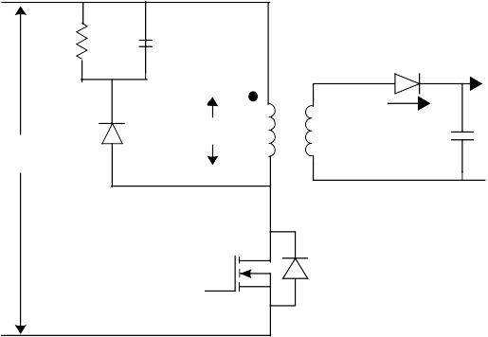

RS CS

D1 IOUT

**(A)**

D2 VP

ID1 S

VOUT

VIN NP

N

ISW

Q1 D

-

**(B)**

**(C)**

Q1PWM

VP

TON

TS VIN

TOFF

t

t VCLAMP

IPK

**(D)**

ISW I1

t

**(E)**

ID1

NP

* IPK

N

S

t

**(F)**

VIN

+ VCLAMP

t

**(A)** = Flyback converter power circuit

**(B)** = Gate pulse for the MOSFET Q1

**(C)** = Voltage across the primary winding

**(D)** = Current through MOSFET Q1

**(E)** = Current through the diode D1

**(F)** = Voltage across the MOSFET Q1

During Continuous Conduction mode of operation, the duty cycle is independent of the load drawn from the converter, and is a constant for the DC input voltage. However, in a practical situation the load increases the loss inside the transformer and the output diode D2 loss is also increased. To maintain constant output voltage, the duty cycle varies slightly in Continuous Conduction mode at a constant DC input voltage.

Because of the presence of the secondary reflected voltage on the primary winding and the leakage stored energy in the transformer core, the maximum voltage stress VDS of the switch is given by Equation 13. If the flyback converter is used for universal input of the off-line power supply, the switch voltage rating should be 700V, considering the secondary reflected voltage of 180V and 20% volts of leakage spike due to leakage energy storage in the transformer.

### EQUATION 13: MAXIMUM VDS IN FLYBACK CONVERTER

*VDS* = *VIN* + *VCLAMP* + *VLEAKAGE*

residual flux density, BR, as shown in Figure 11. Therefore, the air gap increases the working range of delta BH to increase the throughput of the flyback transformer.

### FIGURE 11: BH CURVE WITH AIR GAP

**FOR THE FLYBACK TRANSFORMER**

B BSAT

ΔBAC

H

where:

*VCLAMP* = Voltage across the snubber circuit (D2, R2, and C2)

ΔH ΔH

*VLEAKAGE* = Leakage spike voltage due to leakage energy

without air gap

(air gap)

#### SELECTING A CAPACITOR

The pulsating current ID1, as shown in Figure 10(E), flows in, and the DC load current flows out of the output capacitor, which causes the output capacitor of the flyback converter to be highly stressed. In the flyback converter, the selection of the output capacitor is based on the maximum ripple RMS current seen by the capacitor given by Equation 6, and the maximum peak-to-peak output voltage ripple requirements. The output voltage peak-to-peak ripple depends on the ripple current seen in the capacitor and its Equivalent Series Resistor (ESR). The ESR of the capacitor and the ripple current cause heating inside the capacitor, which affects its predictive life. Therefore, selection of the capacitor depends highly on the ripple current rating and the ESR value so as to meet the temperature rise and output voltage ripple requirement. If the output ripple current is high, it is advisable to have more than one capacitor in parallel in place of a single, large capacitor. These capacitors should be placed at an equal distance from the diode cathode terminal, so that each capacitor shares equal current.

#### AIR GAP

To increase the throughput capability and reduce the chances of magnetic saturation in the flyback transformer core, an air gap is inserted in the limb of the transformer core. This air gap doesn't change the saturation flux density (BSAT) value of the core material; however, it increases the magnetic field intensity, H, to reach saturation and reduces the

#### ADVANTAGES OF FLYBACK TOPOLOGY

Flyback topology is widely used for the output power from a maximum of a 5 to150 watt low-cost power supply. Flyback topology doesn’t use an output inductor, thus saving cost and volume as well as losses inside the flyback converter. It is best suited for delivering a high output voltage up to 400V at a low output power up to 15-20 watts. The absence of the output inductor and the freewheeling diode (used in the forward converter) makes the flyback converter topology best suited for high output voltage applications.

In a flyback converter, when more than one output is present, the output voltages track one another with the input voltage and the load changes, far better than they do in the forward converter. This is because of the absence of the output inductor, so the output capacitor connects directly to the secondary of the transformer and acts as a voltage source during the turned off period (TOFF) of the switch.

#### APPLICATION CONSIDERATIONS

For the same output power level, and if the output current requirement is more than 12-15 amps, the RMS peak-to-peak ripple current seen by the output capacitor is very large, and becomes impractical to handle. Therefore, it is better to use the forward converter topology than the flyback topology for an application where the output current requirement is high.

## Push-Pull Converter

A push-pull converter is a transformer-isolated converter based on the basic forward topology. The basic schematic and switching waveforms are shown in Figure 12.

The high-voltage DC is switched through the center-tapped primary of the transformer by two switches, Q1 and Q2, during alternate half cycles. These switches create pulsating voltage at the transformer primary winding. The transformer is used to step down the primary voltage and to provide isolation between the input voltage source VIN and the output voltage VOUT.

The transformer used in a push-pull converter consists of a center-tapped primary and a center-tapped secondary. The switches Q1 and Q2 are driven by the control circuit, such that both switches should create equal and opposite flux in the transformer core.

In the steady state of operation, when Q1 is ON for the period of TON, the dot end of the windings become positive with respect to the non-dot end. The diode D5 becomes reverse-biased and the diode D6 becomes forward-biased. Thus, the diode D6 provides the path to the output inductor current IL through the transformer secondary NS2. As the input voltage VIN is applied to the transformer primary winding NP1, a reflected primary voltage appears in the transformer secondary.

### FIGURE 12: PUSH-PULL CONVERTER

The difference of voltages between the transformer secondary and output voltage VOUT is applied to the inductor L in the forward direction. Therefore, the inductor current IL rises linearly from its initial value of IL1 to IL2, as shown in Figure 12(E). During this TON period while the input voltage is applied across the transformer primary NP1, the value of the magnetic flux density in the core is changed from its initial value of B1 to B2, as shown in Figure 13.

IL

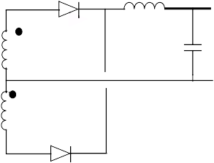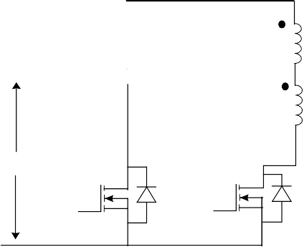

**(A)**

+

VIN

Q2

NP2 NP1

D Q1 D

D6

NS2 NS1

D5

+ L -

IOUT

VOUT

-

**(B)**

Q1PWM

TON

Ts TS/2

TOFF

t

Q2PWM VIN

t

**(C)**

**(D)**

**(E)**

VDS1

IIN

VDS2

IL2 IL

IL1

t

IQ1 IQ2 IQ1 IQ2

t

t

t

**(A)** = Push-pull converter

**(B)** = Gate pulse of MOSFET Q1

**(C)** = Drain-to-source voltage Vds of MOSFET Q1

**(D)** = Current through the MOSFET Q1 and Q2

**(E)** = Output inductor current

At the end of the TON period, the switch Q1 is turned OFF, and remains off for the rest of the switching period TS. The switch Q2 will be turned ON after half of the switching period TS/2, as shown in Figure 12. Thus, during the TOFF period, both of the switches (Q1 and Q2) are OFF. When switch Q1 is turned OFF, the body diode of the switch provides the path for the leakage energy stored in the transformer primary, and the output rectifier diode D5 becomes forward-biased. As the diode D5 becomes forward-biased, it carries half of the inductor current through the transformer secondary NS1, and half of the inductor current is carried by the diode D6 through the transformer secondary NS2. This results in equal and opposite voltages applied to the transformer secondaries, assuming both secondary windings NS1 and NS2 have an equal number of turns. Therefore, the net voltage applied across the secondary during the TOFF period is zero, which keeps the flux density in the transformer core constant to its final value B2. The output voltage VOUT is applied to the inductor L in the reverse direction when both switches are OFF. Thus, the inductor current IL decreases linearly from its initial value of IL2 to IL1, as shown in Figure 12 (E).

#### AVOIDING MAGNETIC SATURATION

After the time period TS/2, when the switch Q2 turns ON, the diode D6 become reverse-biased, and the complete inductor current starts flowing through the diode D5 and transformer secondary NS1. During this TON period, when the switch Q2 is turned ON, the input voltage VIN is applied to the transformer primary NP2 in the reverse direction, which makes the dot end negative with respect to the non-dot end.

As the input voltage applies across the transformer primary NP2, the value of the magnetic flux density in the core is changed from its initial value of B2 to B1, as shown in Figure 13. Assuming the number of primary turns NP1 is equal to NP2, and the number of secondary winding turns NS1 is equal to NS2, the TON period of both switches should be the same to avoid magnetic saturation in the transformer core. After the TON period, Q2 turns OFF and remains off for the rest of the period TS, as shown in Figure 12.

### FIGURE 13: BH CURVE FOR PUSH-PULL

**TRANSFORMERVOLTAGE**

B

BSAT

B2

ΔB

H

B1

BSAT

#### VOLTAGE RATING OF SWITCH

During the TON period of any switch, the voltage VIN is applied to half of the transformer primary and induces equal voltage to the other half of the transformer primary winding. This results in twice the input voltage applied to the off switch. Therefore, the switches used for the push-pull converter must be rated at least twice the maximum input voltage. For practical purposes, the voltage rating of the switch should be 20% more than the theoretical calculation due to leakage spike and transients. For the universal input voltage, the rating of the switch used should be: 264 • 1.414 • 2 • 1.2 = 895, which means a 900 volt switch is required.

VOUT/VIN RELATIONSHIP

In the steady state and Continuous Conduction mode of operation, the relation between the input and output voltage is given by Equation 14, where D is the duty cycle of the switch.

### EQUATION 14: PUSH-PULL CONVERTER

**VOUT/VIN RELATIONSHIP**

⎛ *NS*⎞

*VOUT* = *VIN*

*N* ⎠

⋅ ⎝ ------

*P*

*TON*

* 2 ⋅ *D*

*D* = ----------

*TS*

#### REDUCING MAGNETIC IMBALANCE

If the flux created by both primary windings is not equal, a DC flux is added at every switching cycle and will quickly staircase to saturation. This magnetic imbalance can be caused by an unequal TON period for both switches, an unequal number of turns of the primary NP1 and NP2 and the secondary NS1 and NS2, and an unequal forward voltage drop of the output diodes D5 and D6. This imbalance can be reduced by careful selection of the gate pulse drive circuitry, using a switching device that has a positive temperature co-efficient (PTC) for the ON state resistance, adding air gap to the transformer core, and using peak current mode control techniques to decide the TON period of the switches Q1 and Q2.

Figure 14 explains how to determine the status of magnetics imbalance in the core during the steady state of operation by looking at current waveforms of the two switches Q1 and Q2. If the current wave shape of both switches is symmetrical and equal in magnitude, as shown in Figure 14 (A), the flux excursion in the core is well balanced and the transformer is operating in a safe region. However, if the current wave shape of both switches is not symmetrical and the peak magnitude current is not equal, as shown in Figure 14 (B), there is an imbalance in the flux excursion inside the core; however, it is still operating at the safe operating region of the BH loop. If the current wave shape of one of the switches has upward concavity, as shown in Figure 14 (C), this means there is a large inequality in the flux excursion inside the magnetic core, and magnetic BH loop is close to saturation. A small increase in the magnetic field intensity H will cause a decrease in magnetizing inductance, whereas a significant increase in magnetizing current can destroy the switch and the transformer.

#### FLUX DOUBLING AND VOLT-SECOND CLAMPING

When such a system is first switched ON or during the load transient, the flux density will start from zero rather than B1 or B2, and consequently, the available flux excursion at this instant will be half that normally available under the steady state condition. This is called “flux doubling”. The drive and control circuitry must recognize this condition and protect the application from wide drive pulses until the normal working condition of the core is restored. This is known as “volt-second clamping”.

#### COPPER UTILIZATION

A push-pull transformer requires a center tapped primary, and each winding is active only for alternate power pulses, which means only 50% utilization of primary copper. The unused copper occupies space in the bobbin and increases the primary leakage inductance. A center-tapped primary would normally be bifilar wound, but this will cause a large AC voltage between the adjacent turns.

#### APPLICATION CONSIDERATIONS

The high voltage (2 • VIN) stress on the switch, and 50% utilization of the transformer primary makes using the push-pull topology undesirable when the input voltage is European, Asian, the universal range (90 VAC-230 VAC), or when PFC is used as the front end rectifier. The reason for this is incomplete utilization of magnetic core, which is due to only one switch conducting during each switching cycle and full input voltage is applied across the transformer primary. The push-pull topology is most favorable for low-voltage applications such as US regulation 110 VAC input direct off-line SMPS, or low input voltage DC-DC isolated converter for the power rating of up to 500 watts.

### FIGURE 14: PUSH-PULL CONVERTER SWITCH CURRENT

IQ1 IQ2 IQ1 IQ2

**(A)**

Q1ON Q2ON Q1ON Q2ON

t

**(B)**

t

**(C)**

Saturation

t

**(A)** = Equal volt second is applied across the primary

**(B)** = Unequal volt second applied across the primary but still in safe region

**(C)** = Highly unbalance volt second applied across the secondary and core is near to saturation

#### AVOIDING SHOOT-THROUGH

In a push-pull converter, both switches cannot turn ON at the same time. Turning both switches on at the same time will generate an equal and opposite flux in the transformer core, which results in no transformer action and the windings will behave as if they have a short. This condition offers a very low impedance between the input source VIN and ground, and there will be a very large shoot-through current through the switch, which could destroy it. To avoid shoot-through, an inductor is placed between the transformer primary and the input supply, as shown in Figure 15. The resulted converter is known as a current-source push-pull converter. When both switches are on, the voltage across the primary becomes zero and the input current builds up and energy is stored in the inductor. When only one of the two switches is ON, the input voltage and stored energy in the inductor supplies energy to the output stage.

The relation between the output and input in Continuous Conduction mode is given by Equation 15.

### EQUATION 15: CURRENT SOURCE

**PUSH-PULL CONVERTER VOUT/VIN RELATIONSHIP**

The switches Q1 and Q2 form one leg of the bridge, with the remaining half being formed by the capacitors C3 and C4. Therefore, it is called a half-bridge converter.

The switches Q1 and Q2 create pulsating AC voltage at the transformer primary. The transformer is used to step down the pulsating primary voltage, and to provide isolation between the input voltage source VIN and the output voltage. In the steady state of operation, capacitors C3 and C4 are charged to equal voltage, which results in the junction of C3 and C4 being charged to half the potential of the input voltage.

When the switch Q1 is ON for the period of TON, the dot end of the primary connects to positive VIN, and the voltage across the capacitor C4 (VC4) is applied to the transformer primary. This condition results in half of the input voltage being VIN, which is applied to the primary when the switch Q1 is ON, as shown in Figure 16 (C). The diode D4 becomes reverse-biased, and the diode D3 becomes forward-biased, which carry the full inductor current through the secondary winding NS1. The difference of the primary voltage reflected on the secondary NS1 and output voltage VOUT is applied to the output inductor L in the forward direction. Therefore, the inductor current IL rises linearly from its present value of IL1 to IL2, as shown in Figure 16 (E). During this TON period, the reflected secondary current,

plus the primary magnetizing current flows through the

*VOUT*

⎛ *NS*⎞ ⎛ 1 ⎞

switch Q1. As the voltage is applied to the primary in the

------------- = ⎝ ------

⎠

⎝

⋅ -------------------------

⎠

*VIN*

*NP* 2 ⋅ (1 – *D*)

forward direction during this TON period, and when the

switch Q1 is ON, the flux density in the core changes from its initial value of B1 to B2, as shown in Figure 13.

### FIGURE 15: CURRENT FED PUSH-PULL

**CONVERTER**

D6

VOUT

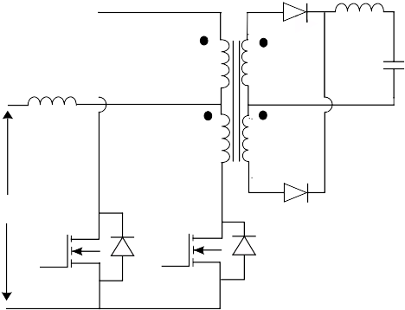

At the end of the TON period, the switch Q1 turns OFF, and remains off for the rest of the switching period TS. The switch Q2 will be turned ON after half of the switching period TS/2, as shown in Figure 16 (B); therefore, during the TOFF period, both switches are off.

+

VIN

NP2 NP1

NS2

NS1

D5

IOUT

When switch Q1 is turned off, the body diode of the switch Q2 provides the path for the leakage energy stored in the transformer primary, and the output rectifier diode D4 becomes forward-biased. As the diode D4 become forward-biased, it carries half of the inductor current through the transformer secondary NS2 and half of the inductor current is carried by the

Q2 D Q1 D

-

NP1

= NP2

= NP

diode D3 through the transformer secondary NS1, as shown in Figure 16 (E). Therefore, the equal and

opposite voltage is applied at the transformer

## Half-Bridge Converter

NS1 = NS2 = NS

secondary, assuming both secondary windings NS1 and NS2 have an equal number of turns. As a result, the net voltage applied across the secondary during the TOFF period is zero, which keeps the flux density in the transformer core constant to its value of B2.

The half-bridge converter is a transformer-isolated converter based on the basic forward topology. The basic schematic and switching waveforms are shown in Figure 16.

The output voltage VOUT is applied to the inductor L in the reverse direction when both switches are OFF. Therefore, the inductor current IL decreases linearly from its initial value of IL2 to IL1, as shown in Figure 16 (E). The body diodes of switches Q1 and Q2 provide the path for the transformer leakage energy.

After the time period TS/2 when the switch Q2 turns ON, the dot end of the primary connects to the negative of VIN, and the voltage across the capacitor C3 (VC3) is applied to the transformer primary. Therefore, half of the input voltage VIN is applied to the primary when the switch Q2 is ON in the reverse direction, as shown in Figure 16 (C). The value of the magnetic flux density in the core is changed from its initial value of B2 to B1, as shown in Figure 13. Assuming the number of secondary winding turns of NS1 is equal to NS2, and to

### FIGURE 16: HALF-BRIDGE CONVERTER

avoid magnetic saturation in the transformer core, the TON period of both switches should be the same. After the TON period, Q2 turns OFF and remains off for the rest of the period TS, as shown in Figure 16 (B). Please note that when either of the switches turn ON for the TON period, it affects the entire input voltage VIN of the other switch.

+

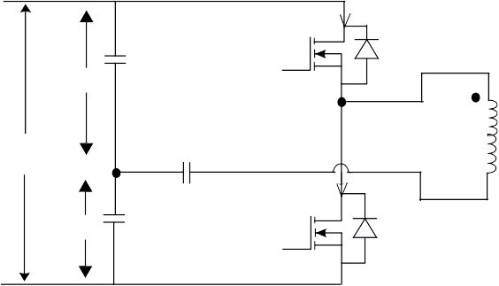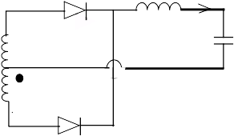

C4 Q1

IQ1

D3 IL

I

OUT

**(A)**

VC4

+

NP NS1

+ L -

VOUT

VIN

-

CB

VC3 C3

IQ2 Q2

VP

- NS2

D4

**(B)**

Q1PWM

TS

TON TOFF

t

Q2PWM

t

**(C)**

**(D)**

**(E)**

VP

ISW

IL2

VIN/2

t

IQ1 IQ2 IQ1 IQ2

t

IL IL1

ID4

t

**(A)** = Half-Bridge Converter

**(B)** = Gate pulse waveform of Q1

**(C)** = Voltage across transformer primary

**(D)** = Current through the switch Q1 and Q2

**(E)** = Output inductor and diode D4 current

#### EQUIVALENT TRANSFORMER

The equivalent transformer model is shown in Figure 17. During the TOFF period, when both switches are OFF, ideally, the secondary currents flowing through the diode D3 and the diode D4 should be equal. However, in the practical sense, because of the presence of the non-zero magnetizing current IM, ID3 and ID4 are not equal.

This magnetizing current IM(t), as shown in Figure 17, may flow through the transformer primary, through one of the secondaries, or it may divide between all three of the windings.

### FIGURE 17: TRANSFORMER

**EQUIVALENT MODEL**

#### DC BLOCKING CAPACITOR

A small DC blocking capacitor is placed in series with the transformer primary, to block the DC flux in the transformer core. The value of the DC blocking capacitor is given by Equation 17.

### EQUATION 17: DC BLOCKING CAPACITOR

*I* ⋅ *T*

*C* = *PRIM ONM*--*A*----*X*-

*B* --------------------------------

Δ*V*

where:

*TONMAX* = maximum ON time of either MOSFET

*IPRIM* = maximum primary current

Δ*V* = permissible droop in primary voltage because of the DC blocking capacitor

I1(t)

+ VP

-

I1 IM(t)

’(t)

NP

NS2 NS1

D3

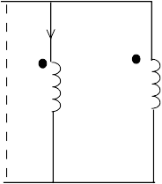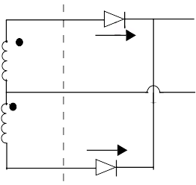

id3

ID4

#### PREVENTING SHOOT-THROUGH

A half-bridge converter is also prone to magnetic imbalance of the transformer core when the flux created by the switches Q1 and Q2 during the TON period is not equal. To prevent staircase saturation, the peak current mode control technique is used to decide the TON period of the switches Q1 and Q2. The

N S = NS1 = N S2 D4 Transformer Equivalent Model

The division of the magnetizing current depends on the I-V characteristics of the switches, the diode and the leakage of the transformer windings. Assuming negligible leakage in the transformer and that both diodes have similar I-V characteristics, the current flowing through the diode D3 and D4 is given by Equation 16.

### EQUATION 16: OUTPUT DIODES AND

**MAGNETIZING CURRENT RELATIONSHIP**

*I*1 = 0

maximum duty cycle of 45% with a dead-time between the two switches is used to prevent shoot-through current from the transformer primary.

#### APPLICATION CONSIDERATIONS

The complete utilization of the magnetic and maximum voltage stress on either of the switches is equal to the input voltage VIN. However, only half of the input voltage is applied across the primary when either of the switches is ON for the TON period. Therefore, double the primary switch current is required to have the same output power as the push-pull converter. This makes the half-bridge topology best suited for applications up to 500 watts. This is especially suited for European and Asian regions where the AC is 230 VAC line voltage. The power rating of the half-bridge converter can be

*ID*3

= 0.5 ⋅ *i*(*t*) – (0.5 ⋅ *n*) ⋅ *IM*

(*t*)

increased up to 650-750 watts if front-end PFC is

used. The peak primary current and the maximum

*ID*4 = 0.5 ⋅ *i*(*t*) – (0.5 ⋅ *n*) ⋅ *IM*(*t*)

*for IM(t)<< i(t)*

*ID*3 = *ID*4 = 0.5 ⋅ *i*(*t*)

transient OFF state voltage stress of the switch determine the practical maximum available output power in the half-bridge converter topology.

## Half-Bridge Resonant Converter

Magnetics and heat sink occupy more than 80% of the total system volume. High switching frequency and high efficiency are the two methods used to improve power density and the profile of a SMPS. However, these two methods do not come together easily. High switching frequency (more than 100 kHz) could reduce the volume of the passive components, but efficiency often suffers as a result. High EMI noises caused by parasitic components prevent fast switching. Efficiency is reduced due to high switching losses, and diode reverse recovery causes voltage overshoot and ringing across the device.

#### Series Resonant Converter (SRC)

In a series resonant converter (SRC), resonant tank elements (the inductor LR and the capacitor CR), are connected in series with the transformer primary, as shown in Figure 18.

**FIGURE 18: SERIES RESONANT**

**CONVERTER**

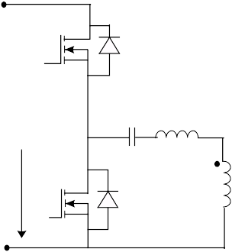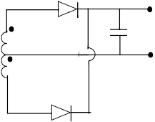

+

#### IMPROVEMENT TECHNIQUES

To develop SMPS with high efficiency and high switching frequencies, and to achieve high power density and low profile, the following techniques need to be improved.

The size of the magnetic components is limited by

VIN

-

CR LR

NS NS

IOUT VOUT

magnetic losses. With the use of better magnetic, the size of the magnetic could be greatly reduced. With better semiconductor switching devices like CoolMOS™, Schottky diode losses in the semiconductor can be reduced. This lessens the thermal management requirement as well as reducing the size and quantity of the heat sink.

Advanced packaging of active and passive components, such as integration of a capacitor into the magnetic, integration of output inductor in the isolation transformer, and the use of the leakage inductance of the transformer when an inductor is required in series with transformer winding, contribute to improving efficiency. In addition, the use of advanced power topologies, which reduce switching losses at higher frequencies.

#### RESONANT TOPOLOGIES

The resonant technique is used to reduce the switching losses in the semiconductor devices. There are many resonant topologies available, such as:

* + Series resonant converter
  + Parallel resonant converter
  + LLC resonant converter

The first two topologies cannot be optimized for the wide input voltage range and wide output load variation. The LLC resonant converter is capable of reducing switching losses at wide input voltage range, and minimizes the circulating energy at high input voltage. Turn off losses can be minimized by reducing the turn-off current through the switch and zero voltage switching (ZVS), thereby eliminating turn-on losses. Therefore, the LLC resonant converter provides negligible switching losses at high switching frequency even at high input voltage variation range.

The resonant tank is used to shape the primary current as sinusoidal, and to reduce the current value flowing through the switch at its transition period, thereby reducing the switching losses. In a power MOSFET, zero voltage switching is preferred as compared to zero current switching. Therefore, the operating switching frequency, more than the resonant tank frequency, is preferred for this type of converter to achieve ZVS, as shown in Figure 19. The operating frequency increases to a very high value at light load (Q = 0) to keep the output voltage regulated.

### FIGURE 19: DC CHARACTERISTICS

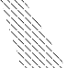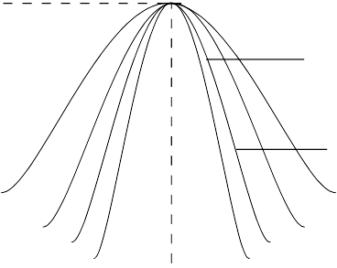

VIN= 300V

VIN = 400V

.2 .4 .6 .8 1.0 1.2 1.4 1.6 1.8

At low input voltage, the converter is operating close to resonant frequency. As the input voltage increases, the converter should operate at a higher switching frequency away from the resonant frequency, thereby increasing more and more circulation energy in the resonant tank, as shown in Figure 20.

### FIGURE 20: CURRENT AND VOLTAGE

**WAVEFORM**



Compared to SRC, the operating region is much smaller at a light load (Q = ∞), as shown in Figure 22.

IR

Circulating

Energy

Circulating Energy

VIN = 300V, full Load

VIN = 400V, full Load

### FIGURE 22: DC CHARACTERISTICS

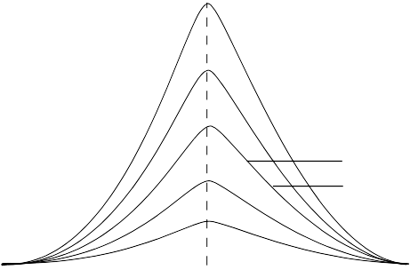

VIN = 300V VIN = 400V

From this analysis, it can be shown that a series resonant converter is not a good choice for a front end DC-DC converter. The major problems are: light load regulation, high circulating energy and turn-off current at high input voltage.



.2 .4 .6 .8 1.0 1.2 1.4 1.6 1.8

### FIGURE 23: CURRENT AND VOLTAGE

**WAVE FORM**

#### Parallel Resonant Converter (PRC)

In a parallel resonant converter (PRC), a resonant tank element, the capacitor CR, is connected in parallel with the transformer primary, as shown in Figure 21. Similar to the SRC, the operation switching frequency is also designed to be more than the resonant tank frequency.

### FIGURE 21: PARALLEL RESONANT

**CONVERTER**

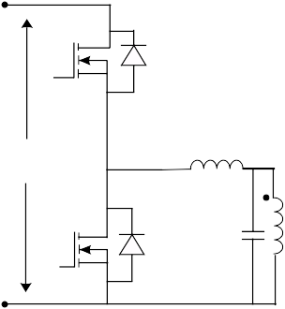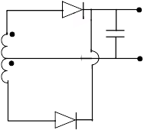

IR

Circulating

Energy

Circulating Energy

VIN = 300V, full Load

VIN = 400V, full Load

+

VIN

-

LR IOUT

VOUT NS

CR

NS

In a parallel resonant converter, since the load is in parallel with the resonant capacitor, even at no load, the resonant tank offers very small impedance to the input, which induces a very high circulation energy. Given the above analysis, we can determine that a parallel resonant converter is not a good choice for a front end DC-DC converter. The major problems are: high circulating energy and high turn-off current at high input voltage conditions.

#### LLC Resonant Converter

In an LLC resonant converter, resonant tank elements (the inductor LR and the capacitor CR), are connected in series with the transformer primary, and the resonant inductor LM is connected in parallel with the transformer primary, as shown in Figure 24.

The LLC resonant converter uses transformer

### FIGURE 24: HALF-BRIDGE LLC

**RESONANT CONVERTER**

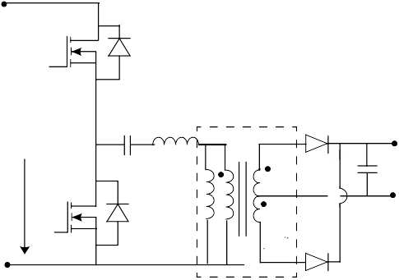

+

Q1

magnetizing inductance for generating one more resonant frequency, which is much lower than the main resonant frequency comprising resonant tank LR and CR. The LLC resonant converter is designed to operate at a switching frequency higher than the resonant frequency of the resonant tank LR and CR.

The benefit of the LLC resonant converter is narrow switching frequency range with light load and ZVS capability even at no load. In addition, its special DC

VIN

Q2

-

CR LR

LM

D1

NS NS

Transformer D2

- IOUT

Vout

gain characteristic, as shown in Figure 25, makes the

LLC resonant converter an excellent choice for the front end DC-DC application. The two resonant frequencies are given by Equation 18. The first

resonant frequency is determined by LR and CR and

### EQUATION 18: LLC RESONANT

**FREQUENCIES**

*F* = ---------------- 1 -------------

*R*1 -----------------

the other resonant frequency is determined by LR, CR and LM.

(2 ⋅ π ⋅

(*LR* ⋅ *CR* ))

1

*FR*2 = -----------------------------------------------------------------

(2 ⋅ π ⋅

((*LM* + *LR* ) ⋅ *CR* ))

### FIGURE 25: DC CHARACTERISTIC OF LLC RESONANT CONVERTER

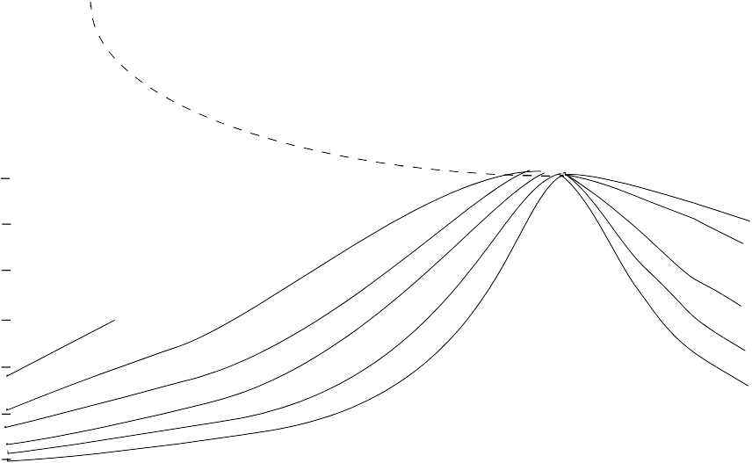

1.8

#### ZVS REGION

1.6

1.4

1.2

#### ZCS REGION

1.0

.8

.6

.4

.2

.2 .6 .8 1

#### LLC Resonant Converter Operation

LLC resonant converter operation can be divided into two time intervals. In the first interval, the inductor LR, resonant with the capacitor CR and inductor LM, is clamped with the output voltage. Resonance of LR and CR is stopped when the LR resonant current is equal to the LM current, after which LM will contribute to the resonance and the second interval begins. During this interval, the resonant components will change to CR and LM in series with LR (see the flat region in Figure 26 (B)). Therefore, the LLC resonant converter is a multi-resonant converter since the resonant frequency at particular time intervals is different.

The detailed operation of the LLC resonant converter, as shown in Figure 26, can be broken down into three modes. At the initial condition, t = t0, the description of the LLC resonant converter operation begins at the conclusion of one power transfer cycle. This occurs after the resonant tank delivering power to the load with switch Q2 is conducting. The resonant current (when Q2 is conducting) flowing through the inductor is negative, as indicated in Figure 26 (B).

##### Mode 1: t0 < t < t1 (Q2 turned OFF at t = t0)

In this mode, the energy stored in the resonant inductor discharges the output capacitor of the switch Q1 to zero potential. The body diode of the switch provides the path for the resonant inductor current LR, which creates a ZVS condition for Switch Q1. The gate signal of Q1 should be applied after the body diode of Q1 starts conducting.

##### Mode 2: t1 < t < t2

This mode begins when inductor current becomes positive, as shown in Figure 26 (B). Since the switch Q1 is turned ON during Mode 1, current will flow through switch Q1. The output rectifier diode D1 becomes forward-biased, and the transformer voltage clamps at output voltage VOUT. The reflected secondary voltage on the primary clamps LM to constant voltage, so it cannot participate in the resonance during this period. This mode comes to an end when LR current is equal to LM current, and the output current reaches zero, as shown in Figure 26 (C).

##### Mode 3: t2 < t < t3

In this mode, when the inductor current LR and LM are equal and the output current reaches zero, both output rectifiers become reverse-biased. During this period, LM is freed to contribute to resonance, and form a resonant tank, CR and LR in series with LM. This mode ends when the switch Q1 turns OFF.

As seen in Figure 26 (B), the switch Q1 turns OFF at a very low value of current compared with peak current. ZVS depends on the magnetizing current and not the load current. This magnetizing current is also the turn-off current of the switch, which can be controlled to achieve almost zero turn-off losses. For the next half cycle, the operation is the same as previously described.

### FIGURE 26: LLC RESONANT CONVERTER

td = Dead time

**(A)**

TON

TOFF

TS

**(B)**

**(C)**

t0 t1

t2 t3

**(A)** = Gate pulse for LLC resonant converter

**(B)** = Resonant magnetizing current

**(C)** = Output current

## Full-Bridge Converter

A full-bridge converter is a transformer-isolated buck converter. The basic schematics and switching waveforms are shown in Figure 27. Since the shape of the converter looks like an H, a full-bridge converter is also known as an H-bridge converter.

#### BASIC OPERATION

The transformer primary is connected between the two legs formed by the switches Q1 Q4 and Q3 Q2. The switches Q1 Q2 and Q3 Q4 create a pulsating AC voltage at the transformer primary. The transformer is used to step down the pulsating primary voltage, as well as to provide isolation between the input voltage source and the output voltage VOUT. As in half-bridge topology, the voltage stress on the switch is VIN. However, voltage applied on the primary when either of the switches is ON is half of the input voltage, thereby doubling the switch current. In a push-pull topology, voltage applied on the transformer primary when either of the switches is ON, is full input voltage; however, the

voltage stress of the switch is twice the input voltage. This condition renders both topologies unfeasible for high power (>500 watt) applications.

A full-bridge converter configuration retains the voltage properties of the half-bridge topology, and the current properties of push-pull topology. The diagonal switch pairs, Q1 Q2 and Q3 Q4, are switched alternately at the selected switching period. In the steady state of operation when the diagonal switch pair, Q1 Q2, is ON for a period of TON, the dot end of the winding becomes positive with respect to the non-dot end. The diode D4 become reverse-biased and diode D3 becomes forward-biased. The diode D3 carries the full load current through the secondary winding NS1. As the input voltage is applied across the transformer primary, the switch carries the reflected load current, plus the transformer primary magnetizing current. The flux density in the core changes from its initial value of B1 to B2, as shown in Figure 13. The difference of the primary reflected voltage to the secondary and the output voltage is applied across the inductor L in the forward direction.

**FIGURE 27: FULL-BRIDGE/H-BRIDGE PHASE SHIFT ZVT CONVERTER**

+ Q1

COSS1

Q3 COSS3

D3 + L

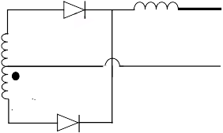

VL

O

- VOUT

**(A)**

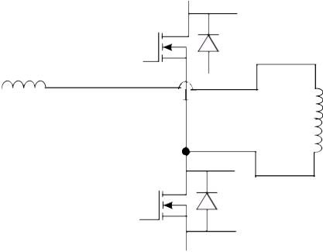

VIN

C LLKG

-

COSS4

Q4

Q2 COSS2 D4

Q1PWM Q2PWM

**(B)**

Q3PWM Q4PWM

TS

TON TOFF

**(C)**

VIN

VIN

**(D)**

**(A)** = Full-Bridge/H-Bridge Phase Shift ZVT converter

**(B)** = PWM gate pulse waveform for full-bridge switches

**(C)** = Voltage across the transformer primary

**(D)** = Output inductor and rectifier diode current

At the end of the ON period, when the switch pair Q1 Q2 is turned OFF, and when it remains OFF for the rest of the switching period TS, the switch pair Q3 Q4 will be turned ON after half of the switching period TS/2, as shown in Figure 27(B and C). Therefore, during the TOFF period, all four switches are OFF.

When the switch pair Q1 Q2 is turned OFF, the body diode of the switch pair Q3 Q4 provides the path for the leakage energy stored in the transformer primary.The output rectifier diode D4 becomes forward-biased, and it carries half of the inductor current through the transformer secondary NS2. Half of the inductor current is carried by the diode D3 through the transformer secondary NS1, as shown in Figure 27 (D). Therefore, the net voltage applied across the secondary during TOFF period is zero as previously discussed in half-bridge topology operation. This keeps the flux density in the transformer core constant to its final value of B2 (see Figure 15). The output voltage VOUT is applied to the inductor L in the reverse direction when both switches are OFF.

After the time period TS/2, when the diagonal switch Q3, Q4 is turned ON for a period of TON, the dot end of the winding becomes negative with respect to the non-dot end. The diode D3 becomes reverse-biased and the diode D4 becomes forward-biased. The diode D4 car- ries the full load current through the secondary winding NS2. As the input voltage is applied across the trans- former primary, the switch carries the reflected load current plus the transformer primary magnetizing cur- rent. As the input, voltage is applied to the transformer in the reverse direction, the flux density in the core changes from its initial value of B2 to B1, as shown in Figure 13. The difference of the primary reflected volt- age to the secondary and the output voltage is applied across the inductor L in forward direction.

Assuming the number of secondary winding turns NS1 is equal to NS2, and to avoid magnetic saturation in the transformer core, the TON period of both switch pairs Q1 Q2 and Q3 Q4 should be equal. After the TON period of the switch pair Q3 Q4, it turns OFF and remains OFF for the rest of the period TS, as shown in Figure 27 (B). Please note that when either of the diagonal switch pairs turns ON for a period of TON, it applies the entire input voltage VIN to the other switch.

In Continuous Conduction mode of operation, the relation between the input voltage and the output voltage is given by Equation 19.

### EQUATION 19: FULL-BRIDGE CONVERTER

**VOUT/VIN RELATIONSHIP**

⎛ *NS*⎞

#### APPLICATION CONSIDERATIONS

Since the maximum voltage stress across any switch is VIN, and with the complete utilization of magnetic core and copper, this combination makes the full-bridge con- verter an ideal choice for high input voltage, high power range SMPS (<1000 watts) applications.

#### Full-Bridge Converter

In the full-bridge converter, four switches have been used, thereby increasing the amount of switching device loss. For applications requiring output power of more than 1000 watts, the loss in the switching device becomes impractical to handle in a full-bridge converter.

The conduction loss of a MOSFET can be reduced by using a good MOSFET, and switching losses can be reduced by using either a ZVS (zero voltage switching during turn ON transition), a ZCS (zero current switching during turn OFF transition), or both techniques. Shaping the input current sinusoidal to achieve ZCS, increases the peak and the RMS current through the MOSFET in the high power application, thereby increasing the conduction losses. At high input voltage, the ZVS technique is preferred for the MOSFET.

#### Full-Bridge/H-Bridge Phase-Shift ZVT Topology

A full-bridge converter using the phase shift ZVT technique is known as an H-Bridge Phase-Shift ZVT topology. In this topology, the parasitic output capacitor of the MOSFETs and the leakage inductance of the switching transformer are used as a resonant tank circuit to achieve zero voltage across the MOSFET at the turn-on transition. There are two major differences in the operation of a phase-shift ZVT and simple full-bridge topology. In a phase-shift ZVT converter, the gate drive of both of the diagonal switches is phase shifted. In addition, both halves of the bridge switch network are driven through the complementary gate pulse with a fixed 50% duty cycle. The phase difference between the two half-bridge switching network gate drives control the power flow from primary to secondary, which results in the effective duty cycle.

Power is transferred to the secondary only when the diagonal switches are ON. If either the top or bottom switches of both legs are ON simultaneously, zero voltage is applied across the primary. Therefore, no power is transferred to the secondary during this period. When the appropriate diagonal switch is turned OFF, primary current flows through the output capacitor of the respective MOSFETs causing switch drain volt- age to move toward to the opposite input voltage rail. This causes zero voltage across the MOSFET to be

turned ON next, thus creating zero voltage switching

= ⋅ ⋅ ⎝ ------ ⋅ *D*

*VOUT* 2 *VIN* ⎠

*N*

*P*

when it turns ON. This is possible when enough circu- lating current is provided by the inductive storage energy to charge and discharge the output capacitor of

the respective MOSFETs. Figure 28 shows the gate pulse required, and the voltage and current waveform across the switch and transformer.

### FIGURE 28: REQUIRED GATE PULSES AND VOLTAGE AND CURRENT ACROSS PRIMARY

Q1PWM

**(A)**

Q4PWM

Q2PWM

Q3PWM

**(B)**

**(C)**

VPRIMARY

IPK IP

t0 t1 t2 t3 t4

**(A)** = Gate pulse for all switches for phase-shift ZVT converter

**(B)** = Voltage across primary

**(C)** = Current across primary

#### TIME INTERVALS

The operation of the phase-shift ZVT can be divided into different time intervals. Assuming that the transformer was delivering the power to the load, the current flowing through primary is IPK, and the diagonal switch Q1, Q2 was ON, at t = t0, the switch Q2 is turned OFF.

##### Interval1: t0 < t < t1

The switch Q2 is turned OFF, beginning the resonant transition of the right leg. Primary current is maintained constant by the resonant inductor LLK. This primary current charges the output capacitor of switch Q2 (COSS2) to the input voltage VIN, which results in the output capacitance of Q3 (COSS3) being discharged to zero potential. This creates zero potential across the switch Q3 prior to turn-on, resulting in zero voltage switching. During this transition period, the transformer primary voltage decreases from VIN to zero, and the primary no longer supplies power to the output. Inductive energy stored in the output inductor and zero voltage across the primary cause both output rectifiers to share the load current equally.

##### Interval2: t1 < t < t2

After charging COSS2 to VIN, the primary current starts flowing through the body diode of Q3. Now Q3 can be turned on any time after t1 and have a zero voltage turn-on transition.

##### Interval3: t2 < t < 3

At t = t2, Q1 was turned OFF and the primary was maintained by the resonant inductor LLK. In addition, at t = t2, IP is slightly less than the primary peak current IPK because of finite losses. The primary resonant current charges the output capacitor of switch Q1 (COSS1) to input voltage VIN,

*R*

##### Interval: t3 < t < t4

The two diagonal switches Q3, Q4 are ON, applying full input voltage across the primary. During this period, the magnetizing current, plus the reflected secondary current into the primary flows through the switch. The exact diagonal switch-on time TON depends on the input voltage, the transformer turns ratio, and the output voltage. After the TON period of the diagonal switch, Q3 is turned OFF.

One switching cycle is completed when the switch Q3 is turned OFF. The primary current charges COSS3 to a potential of input voltage VIN and discharges COSS2 to zero potential, thereby enabling ZVS for the switch Q2. The identical analysis is required for the next half cycle.

#### ACHIEVING ZVT

In the H-Bridge Phase Shift ZVT Converter shown in Figure 27 (A), the maximum transition time occurs for the left leg at minimum load current and maximum input voltage, and minimum transition time occurs for the right leg at maximum load current and minimum input voltage. Therefore, to achieve ZVT for all switches, enough inductive energy must be stored to charge and discharge the output capacitance of the MOSFET in the specified allocated time. Energy stored in the inductor must be greater than the capacitive energy required for the transition as given by Equation 20. The MOSFET output capacitance varies as applied drain-to-source voltage varies. Thus, the output capacitance of the MOSFET should be multiplied by a factor of 4/3 to calculate the equivalent output capacitance.

### EQUATION 20: RESONANT ELEMENTS LR

**AND CR RELATIONSHIP**

which discharges the output capacitor of Q4 (COSS4) to zero potential, thus enabling zero

0.5 ⋅ *LR* ⋅ *IP RIMIN*

2

2 > *C*

* *VINMAX*

2

2

voltage turn-on switching for Q4. During this

transition, the primary current decays to zero. ZVS of the left leg switches depends on the energy

where:

*LR* ⋅ *IPRIMIN*

> *CR* ⋅ *VINMAX*

stored in the resonant inductor, conduction losses in the primary switches, and the losses in the transformer winding. Since this left leg transition depends on leakage energy stored in the transformer, it may require an external series inductor if the stored leak energy is not enough for ZVS. Now, when Q4 is turned ON, voltage VIN is applied across the primary in the reverse direction.

LR = equivalent leakage inductor

CR = equivalent capacitor required to charge and discharge

= output capacitor of two switches in parallel with parasitic

# METHOD OF CONTROL

All switching converter output voltage is a function of the input voltage, duty cycle and load current, as well as converter circuit component values. The output voltage should be constant regardless of variation in input voltage, load current and converter circuit parameter values. The input voltage may vary from 90 VAC to 264 VAC, and input frequency from 47 Hz to 63 Hz for an off-line power supply, and -25% to +50% from the nominal value for the DC input supply. The load current may vary from no load to full load. In addition, the load may vary from no load to 50% load in step, and vice versa. The converter circuit components will have some tolerance. Despite variation, it is desired that the output voltage be within a certain limit. This is not practical to achieve without negative feedback, and setting the duty cycle to a single value. There are two basic methods to control the duty cycle to keep the output voltage within the specified limit: voltage mode control and current mode control.

## Voltage Mode Control

In voltage mode control, the output voltage is measured and then compared with the reference value (desired output voltage). The error is then processed by the compensation block to generate the next duty cycle value, as shown in Figure 29. This mode has only one control loop, so it is easy to design and analyze. However, in this control method, any change in the line or the load must be first sensed as an output voltage change and then corrected by the feedback loop. Therefore, the response is slow and the transient response (step load change) is not favorable. Adding input voltage feed-forward to this control scheme will reduce the effect of input voltage variation in the output.

### FIGURE 29: VOLTAGE MODE CONTROL

VOUT

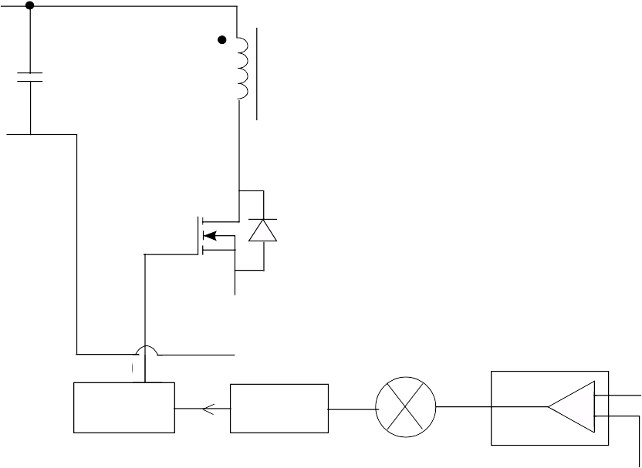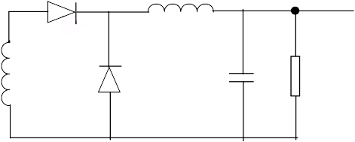

VIN Load

Drive Circuit

PWM

Comparator Block

VREF -

x

x +

Compensator

|  |  |
| --- | --- |
|  |  |
| Voltage  Feed Forward Block | |

Block Output Voltage

Reference

VIN

## Current Mode Control

The current mode control technique requires two feedback loops, as shown in Figure 30. In this mode, two parameters are measured for control purposes. The output voltage is measured at the output capacitor or at the load end (known as remote sensing). The output inductor/primary switch current is also measured.

In current mode control, the output voltage is first compared with the reference voltage (desired output voltage). This error is then processed by the compensation block to generate the reference signal for the current loop. This current reference is compared to the measured current. Any error generated by the comparison of the reference generated by the voltage compensation block and the actual current drawn from

the input is processed by the current compensation block. This generates the required duty cycle to maintain the output voltage within the specified limit. As current mode control senses the circuit current, any change in output load current or the input voltage can be corrected before it affects the output voltage.

Sensing the input current, which depends on input voltage, provides the inherent feed-forward feature. Current mode control provides inherent input current symmetry for the push-pull and bridge converters, inherent current limiting features and load sharing features for multiple converters connected in parallel. It also improves step load response and transient response because of the inner current loop.

### FIGURE 30: CURRENT MODE CONTROL

VIN

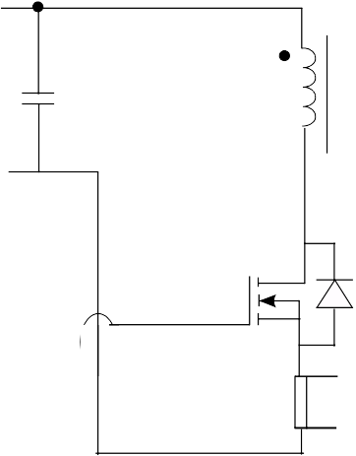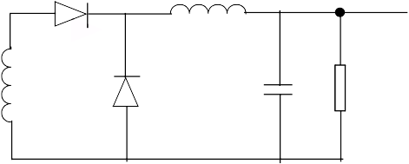

VOUT

Load

RS

Current sense amplifier with isolation

RS

|  |  |
| --- | --- |
| Current sense  amplifier | |
|  |  |

Drive Circuit

PWM

Compensator Block

IERR

IREF -

+

Compensator

Block Output Voltage

reference

### TABLE 1: CONTROL METHODS AND CHARACTERISTICS

|  |  |  |  |
| --- | --- | --- | --- |
| **Mode** | **Converter** | **Speed** | **Description** |
| Voltage | Buck, Forward | Slow | Output short protection, no pulse by pulse protection |
| Current | Boost, Flyback, Push-Pull, Half- and Full-bridge | Fast | Output short circuit and OC protection, pulse current protection |

## Power Diode

A power diode requires a finite time to change from the blocking state to the conduction state and vice versa. The time required to change its state, and how the diode current and voltage change during the transition period affects the operation of circuitry. The shape of the waveform (voltage and current) and transition time depends on diode intrinsic properties.

#### CHARACTERISTICS

Figure 31 shows how the voltage and current varies in the power diode during the transition period. During the period t1, space charge is stored in the depletion region due to the growth of forward current and removal of reverse voltage. During period t2, because of diode forward current, excess carriers distributed in the drift

region settle toward a steady state value. If a large ΔI/Δt

is applied to the diode, voltage overshoot is observed due to the presence of ohmic resistance in the drift region, the inductance of the silicon wafer and the bonding wires attached to it.

At the turn-off transition, as shown in Figure 31, and during the period t3, the excess charge stored in the drift region is removed before the junction becomes reverse-biased during period t4. This recombination process of the depletion layer acquires a substantial amount of charge from the reverse-biased voltage. As long as there is excess charge in the drift region diode, it will be forward-biased.

After the t4 junction becomes reverse-biased, and after the time period t4, the diode current no longer goes negative and quickly falls and becomes zero after t5.

Reverse recovery current reaches its maximum value at the end of t4. In almost all of the power circuit configurations, this reverse recovery current of the diode will flow through the next MOSFET to turn ON. So, while fixing the MOSFET current rating, the reverse recovery current of the diode must be added.

A Schottky diode is a majority carrier device and has no stored minority carrier; therefore, a Schottky diode turns ON and OFF faster than a PN junction power diode. A Schottky diode also improves the switching characteristics and the forward voltage drop of the diode by placing a thin film of metal in direct contact with a semiconductor.

The forward voltage drop of a Schottky diode is 0.3-0.4V, and has a larger reverse current than the comparable silicon power diode. Because of its physics, the breakdown voltage of the Schottky diode at present cannot be more than 150-200V. At turn-off there will be no reverse recovery current because there is no stored charge. Ohmic resistance of the drift region is much less than that of the PN junction diode, resulting in considerably less voltage overshoot during device turn ON.

The diode total loss in the circuit is given by Equation 21, which consists of forward voltage drop loss, reverse recovery loss, and reverse leakage current loss.

**FIGURE 31: POWER DIODE SWITCHING CHARACTERISTICS**

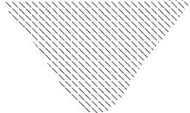

IF

~

ΔIF/ΔT IF

0 t3

QRR = IRR • TRR/2

t IRR

t4 t5

VFP VF

~

TRR

VON 0

VR t

VRR

t1 t2

### EQUATION 21: DIODE LOSS

*PLOSS* = *VF* ⋅ *IFAVG* + 0.5 ⋅ *t*5 ⋅ *VR* ⋅ *IREC* ⋅ *F* + *IREVA VG* ⋅ *VR*

where:

*PLOSS* = Total diode loss

*VF* = Forward voltage drop

*IFAVG* = Average forward current

*VR* = Reverse blocking applied across the diode

*IREC* = Peak reverse recovery current

## MOSFET

Appreciable current carrying capability, high reverse blocking voltage, very low ON resistance and fast switching capabilities make a MOSFET an ideal choice as a switching element in SMPS topologies.

A MOSFET is a majority carrier and a voltage driven device, whereas a Bipolar Junction Transistor (BJT) is a minority carrier and a current driven device. The ON state resistance of a MOSFET has no theoretical limit, so the ON state loss can be far lower than a BJT. The ON and OFF switching time of a MOSFET depends on the presence or absence of a key charge quantity in the device, and is equal to the time required to insert or remove this controlling charge quantity.

The total amount of controlling charge in the majority

After CGS is charged to VGTH, the drain current begins rising from zero to the rated value. During this period, the gate current charges both capacitors, CGS and CGD. The drain-to-source voltage remains at VDS so long as the drain current (ID) reaches the rated value (ID). The time required for drain current to reach its rated value ‘ID’, as shown in Figure 33, is known as the current rise time TRI. When drain current reaches ID, VGS is clamped to VGSID, as shown in Figure 33, and the entire gate current starts flowing through CGD to charge it. This causes the drain-to-source voltage VDS to drop. The rate of change of VDS is given by Equation 22.

### EQUATION 22: RATE OF CHANGE OF VDS

(*VG* – *VGSID*)

= -----------------------------

carrier device is much less than the charge required in

the equivalent minority carrier device. This causes the

*IGATE*

----

*RG*

majority charge carrier device to turn ON and OFF

Δ*VDS IG*

------------- = ----------

faster than a minority carrier device. A MOSFET has positive temperature coefficient for the ON state resistance, which makes it easy to parallel many small devices to deliver higher current. Figure 32 shows an equivalent circuit diagram of a MOSFET with a parasitic capacitor and body diode.

### FIGURE 32: MOSFET

Drain (D)

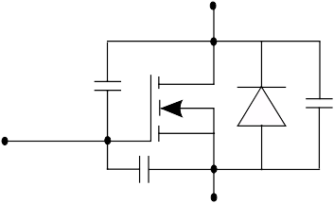

CGD

CDS

Δ*t CGD*

VDS decreases VD to VDSON in two intervals. The first interval is known as the active region and the second interval is known as the transient ohmic region. Once the MOSFET enters the ohmic region, the gate-to-source voltage starts to rise toward VG, while simultaneously, the gate current decays to zero. In a practical system, the freewheeling diode has some reverse recovery current IRR. At this moment, during the drain current rising period, the drain current rises to the value ID + IRR, and then VDS starts to decay to VDSON. After the decay of the reverse recovery current

to zero, ID clamps to LD.

Gate (G)

CGS

Source (S)

The sequence is reversed when the MOSFET is turned OFF. The gate-to-source voltage first decays to VGSID, and then the drain-to-source voltage starts rising

toward VDS, as shown in Figure 34. When the

The turn-on switching waveforms of the drain-to-source

voltage and drain current with gate-to-source voltage are shown in Figure 33. The rate of change of drain current depends on the rate at which the gate-to-source capacitor is charged by the gate drive circuit.

The time required to charge the gate capacitor to VGTH (gate threshold voltage) is known as turn-on delay (td). This assumes the gate drive voltage rises from zero to VG at t = t0, and it is driving the MOSFET gate through gate resistance RG.

drain-to-source voltage reaches its rated value, VDS, the drain current begins to decay toward zero, and the gate-to-source voltage and gate current decays to zero, as shown in Figure 34. The time required for the gate source voltage to reach VGSID is known as turn-off delay.

#### MOSFET LOSSES

There are three types of losses in a MOSFET: conduction loss, switching loss and gate charge loss. At low frequencies, conduction loss is dominant, but as we begin switching at frequencies between 100-150 kHz, switching and gate charge losses start contributing a significant amount of power dissipation. The total losses in a MOSFET in power electronic circuitry is given by Equation 23.

#### Conduction Loss

Conduction loss depends on the ON state resistance of MOSFET (RDSON), which can be reduced by selecting a low RDSON MOSFET.

#### Switching Loss

The switching losses of the MOSFET are given by the area under the waveforms of VDS and ID, shown shaded in Figure 33 and Figure 34, and the charge stored in the parasitic output capacitor CDS during the turn OFF period of the MOSFET. The switching losses of the MOSFET can be reduced by selecting a MOSFET with lower CDS capacitance and shifting the current ID and the voltage VDS waveform to reduce the overlap period during transition.

#### Gate Charge Loss

Gate charge loss is caused by charging the gate capacitance and then dumping the charge to ground in every switching cycle.

#### APPLICATION CONSIDERATIONS

A lower RDSON device comes with high gate capacitance and the driver has to charge bigger gate capacitance, which means a longer turn-on and turn-off time, resulting in more switching losses. The general rule of faster switching time to reduce the switching loss will cause high frequency noise because of high ΔV/Δt and high ΔI/Δt, which may cause an increase of the EMI filter size.

The safe operating area (SOA) of a MOSFET is decided by maximum drain current IDMAX, Internal junction temperature TJ, and the breakdown voltage BVDS rating. There is no second breakdown voltage in a MOSFET as in the case of IGBT, and the SOA of the MOSFET remains the same in the reverse direction. In addition, a MOSFET can conduct in either direction while keeping the same RDSON.

While selecting a MOSFET driver, care must be taken to ensure that the driver can source and sink the maximum peak current required by a MOSFET gate to turn ON and OFF in a given specified time. A MOSFET gate needs large current as the device turns ON, and for the rest of the period, a high gate-to-source voltage at low current level.

### EQUATION 23: MOSFET LOSS

= 2 ⋅ *R*

+ 0.5 ⋅ *V*

* *I* ⋅ (*T* + *T*

) ⋅ *f*

+ 0.5 ⋅ *V*

2 ⋅ *C* ⋅ *f* + *Q*

* *V* ⋅ *f*

*PSW IDRMS*

where:

*DSON*

*DS D*

*RISE*

*FALL SW*

*DS DS SW*

*GTOTAL*

*G SW*

*IDRMS* = Drain RMS current

*TRISE* = Rise time

*TFALL* = Fall time

*fSW* = Switching frequency *QGTOTAL* = Total gate charge *CDS* = MOSFET output capacitor *VDS* = Drain-to-source voltage

*ID* = Drain current

*VG* = Gate voltage

*RDSON* = ON state resistance of the MOSFET

### FIGURE 33: MOSFET TURN ON CHARACTERISTICS

VG



VGS(ID)

τ1 = RG(CGD + CGS)

VGS(t)

VGS(th)

IG(t) 0

t

VD

ID

VDS(on)

0

td(on)

t TRI

### FIGURE 34: MOSFET TURN OFF CHARACTERISTICS

VG



VGS(t)

t IG(t)

VDS

VDS(t)

ID(t)

ID

TFI t

## Snubbers

There are two basic ways to solve the problem of a semiconductor device that is stressed beyond its rating. Either the device can be replaced with a higher rated device to meet the stress level, or a snubber circuit can be added to reduce the stress to a safe level. Both options are trade-offs between cost, availability of the higher rated device, complexity, component count and the cost of using a snubber circuit.

A snubber circuit is typically used to limit the rate of rise of voltage (ΔV/Δt), the voltage applied across the

Figure 36 shows the common turn-off snubber circuitry used to limit the ΔV/Δt and reduce the switching losses in the MOSFET. When the MOSFET turns OFF, some of the peak current starts flowing through CS, which causes it to slow the drain voltage rise time, and reduce the area under the VDS and ID during turn-off time. CS has to completely discharge during the minimum TON

time of the MOSFET, which limits the maximum value of CS that can be used, is given by Equation 25.

### EQUATION 25: SNUBBER CAPACITOR

= *TONM*-----*I*-*N*--

-----------

device during turn-off, the rate of rise of current (ΔI/Δt)

and the current through the device during turn-on.

Figure 35 shows some of the popular snubber circuitry

where:

*C*

4 ⋅ *RS*

*S*

used across the transformer primary in a single switch power converter application to limit the ΔV/Δt and blocking voltage applied across the MOSFET during turn-off.

The simple design of the RCD snubber, as shown in Figure 35 (A), is to first choose the capacitor CS large enough so that it contains negligible switching ringing, and then choose RS so that the power dissipated in RS at VS (voltage across the capacitor CS) is equal to the

*RS* = Snubber resistor

*CS* = Snubber capacitor

*TONMIN* = Minimum ON time of switch

When the MOSFET turns OFF, CS charges to voltage VS, so energy is dissipated during each switching cycle in the snubber resistor is given by Equation 26.

### EQUATION 26: SNUBBER POWER LOSS

switching loss caused by the leakage inductance as given in Equation 24.

where:

*S*

*S*

*PRS*

= 0.5 ⋅ *V* 2 ⋅ *C*

* *fSW*

### FIGURE 35: TURN OFF SNUBBERS

*VS* = Voltage across the snubber capacitor *CS*

VIN

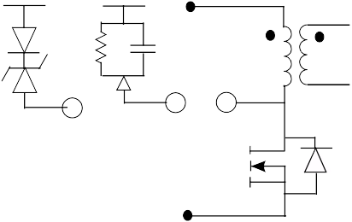

VIN

VIN

*fSW* = Switching frequency

1

**(B)**

1 1

**(A)**

### FIGURE 36: MOSFET TURNS OFF

**SNUBBER**

Q

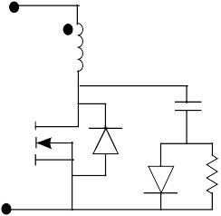

### EQUATION 24: SNUBBER RESISTOR

**SELECTION**

CS Q

DS RS

2

*V*

*S* 2

where:

-------- = 0.5 ⋅ *LLK* ⋅ *I RS*

* *fSW*

*I* = The current flowing through the transformer primary just before the MOSFET turns off

*LLK* = *LLEAKAGE* inductance of the transformer

# MAGNETICS DESIGN

This section covers the basics of magnetic design used in SMPS applications. After selecting the topology that is best suited to the power supply specification, the next choice is to fix the switching frequency and transformer core size. To do this, it is necessary to know the numerical relation between maximum available power and transformer parameters such as magnetic core area, magnetic length, window area, bobbin area, peak flux density and coil current density.

There are two types of magnetic losses: hysteresis and eddy current. Ferrite has high electrical resistivity, so typically there are only negligible hysteresis and eddy current losses. This makes ferrite a good material to use for a switching frequency of 10 kHz to 1 MHz.

Table 2 lists some of the pros and cons of the magnetic material used in high frequency transformer and inductor design.

### TABLE 2: MAGNETICS MATERIAL AND THEIR CHARACTERISTICS

|  |  |  |
| --- | --- | --- |
| **Material** | **Pros** | **Cons** |
| Ferrite | High permeability, thus can be used to generate high inductance, permeability is relatively constant with flux density, and variety of ferrite is available optimized for minimum power dissipation for various frequencies. Generally used for power transformers. | Ferrite saturates hard |
| Molyperm MPP | Soft saturation, a wide variety of different permeability is available. Generally used for power Inductors. | Considerably higher losses than ferrites |
| Powdered Iron | Variety of permeability is available, and it is less expensive than the MPP. Generally used for power inductors where cost is more important. | Saturates slightly harder than MPP, a powdered iron core inductor will be larger in size than an inductor made from MPP or ferrite. |

**Transformer Design**

Transformer size depends on many parameters such as: core loss, copper loss, cooling efficiency, insulation, core geometry, and the maximum throughput power. Core loss increases as the flux density swings and the core size increases. Copper loss increases as the flux density and core size decreases. When operating at or

Once the numerical relation is known, the area product core size can be selected. The number of primary turns is given by Equation 28.

### EQUATION 28: TRANSFORMER PRIMARY

**NUMBER OF TURNS**

*TONMAX*

= ⋅ -----------------------

near 100 kHz, maximum efficiency occurs at 40-45% of

core loss and 55-60% of copper loss.

The first step in the transformer design is to fix the core

*NP VINMIN*

(*AE*

* Δ*B*)

and the bobbin size. The power rating of the core is relative to the product of the core window area and the core cross-sectional area (known as the area product), which is readily available from the core manufacturer.

The window area used for the primary winding is given by the primary area factor KP and primary utilization

factor KU. The numerical relation between the core

The number of secondary turns for the center tap transformer is given by Equation 29.

### EQUATION 29: TRANSFORMER

**SECONDARY NUMBER OF TURNS**

geometry, area product and power output is given by

*N*

*N V* ---------------------

*P*

-----------

Equation 27.

*S* = *O* ⋅

-----------------

(*VINMIN* ⋅ 2 ⋅ *DMAX* )

### EQUATION 27: CORE GEOMETRY AND

**POWER OUTPUT RELATIONSHIP**

*DMAX* 4

When testing the transformer in the actual application, some fine tuning may be required to improve its overall performance. For a given transformer, if the power loss

in the core is much less than copper loss (primary and

= ⋅ =

⋅----------------------------------------

⋅108 ⋅*C*

*AP AE AW PIN* (*K* ⋅ *J* ⋅ *f*

*SW*

where:

*AE* = Core cross section area

*AW* = Core window area

*AP* = Area product

* Δ*B*) *M*

secondary together), decreasing the number of turns will be required. This interim increases the flux density. And, if core loss in substantially lesser than copper loss, an increase in the number of turns is required, which reduces the flux density to optimize the total loss (core loss plus copper loss). The winding area in the primary and secondary should be proportional to their

*PIN* = Power input = power output

*DMAX* = Maximum duty cycle of switch

*K* = *KP • KU* • *KT* = overall copper utilization factor

*J* = Current density of primary

*fSW* = Switching frequency

*B* = Change in flux density during ON time

*KT* = Ratio of primary average to RMS current

losses. If multiple secondary windings are present, the

winding area should be proportional to the copper loss.

**Inductor Design**

An inductor is a magnetic component that has a single winding in its core and carries a primarily DC current along with AC ripple, which is generally very small compared with DC current. For power inductors, a toroid is the most commonly used core geometry.

For a power inductor design, two parameters must be known: the inductance required with the DC bias and the value of the DC current. The following procedure defines how to choose the core size and the number of turns required. The design example is based on the MPP core selector chart from the manufacturer MAGNETICS (see Figure 37).

1. Calculate the number of turns from the AL value, given by the core manufacturer.
2. Calculate the magnetic field strength in oersteds from the magnetic data sheet provided by the manufacturer.
3. From the permeability versus DC bias curve, determine the percentage of initial permeability.
4. Calculate the actual number of turns required, based on initial permeability value.

### EQUATION 30: INDUCTOR NUMBER OF TURNS

6

1. Calculate the energy storage requirement for the inductor. The data provided by the manufacturer is L • I2; therefore, compute E = L• I2, where L is the inductance value and I is the DC current flowing through the inductor. For example, the required inductance of 500 µH for

3 amps DC current would be: E = 4.5 mJ.

1. Locate the value E in the core selector chart, as shown in Figure 37. This graph is provided by the manufacturer. Follow this coordinate to the intersection with the first core size. Here it passes through the 125µ section of permeability and the smallest core that can be used is the 55310 MPP core.

= *LR EQUIRED* ⋅ 10 -

----------------------------------------

*N*

*AL*

106

*N* = 0.5 ⋅ --------

90

*N* = 75 *turns*

2-------.-8-- ⋅ 75 ⋅ 3 = 50.04

125

*N* = 89

### FIGURE 37: ENERGY VERSUS CORE SIZE

**MPP Core Selector Chart**

55908

55868

55440

55091

**Cores Listed by Geometry Factor**

55083

55071

55586

55310

55378

55045

55035

55275

55285

55235

55175

300µ

200µ

160µ

125µ

60µ

26µ

55191

55111

55716

55076

55894

55350

55204

55118

55125

55285

55405

55025

55015

55145

55135

0.0001 0.001 0.01 0.1 1 10 100 1000

### LI2, mH-amperes2

## Selection of Capacitors

The selection of the input bulk capacitor depends mainly on the hold-up time required from the power supply, and the ripple RMS current rating of the capacitor. Selection of the output capacitor depends on the maximum operating RMS current, switching frequency, lifetime and the type of the converter used.

The Equivalent Series Resistor (ESR) of the output capacitor directly affects the output ripple voltage and life of the capacitor. Figure 38 shows the current and voltage waveform across the output capacitor, which has a ΔI ripple amplitude centered at the output load current IOUT. The product of ΔI with the ESR of the capacitor provides the peak-to-peak ripple voltage ΔV at the output voltage.

The life of the capacitor doubles with every 10 degree drop in temperature from its rated value. For example, if the capacitor is rated at 5000 hours at 105°C, it would

have a life span of 5000 • 24, which equals 80,000

hours at a 65°C operating temperature.

Table 3 shows the type of capacitors and the applications where they are typically used.

### FIGURE 38: INDUCTOR CURRENT AND OUTPUT CAPACITOR VOLTAGE WAVEFORM

IOUT



ΔI

IOUT

ΔV

VOUT

### TABLE 3: CAPACITORS AND THEIR CHARACTERISTICS

##### Type of Capacitor Typical Application

Aluminum Electrolytic Generally used at converter input and output where capacitance required is

large and size of the capacitor is not important.

Tantalum Generally used at output of converter where it requires high ripple current RMS rating and low ESR of capacitor and size and footprint requirement is very small. It generally comes in a SMD package.

Ceramic and Multilayer Ceramic Used for signal and timing application. Used in parallel with electrolytic

capacitor for noise filter.

Film, Polypropylene Generally used for safety application like X- and Y-type capacitors.

# ELECTROMAGNETIC INTERFERENCE (EMI) IN SMPS

One of the biggest challenge faced by a power supply engineer is to design a power supply that meets the specification, which calls for EMI and EMC limits. In this application note, only EMI and more particularly, practical aspects of EMI are discussed.

There are two types of noise: conducted and radiated. The most fundamental difference is that the conducted noise is carried by the conductor and the radiated noise does not rely on the conductors.

## Best Practices

A good PCB layout and good wiring practice drastically reduces the radiated noise. The high frequency current loop should be short. A twisted pair of conductors should be used. A transformer and an inductor with air gap should be screened to reduce the radiated magnetic field. The best practice is to keep the line and return path for any signal as close as possible to each other, since signal level is directly proportional to the loop area formed by the signal wires. Also, use metal for the enclosure box material.

There are two types of conducted noise: the differential mode noise that flows in one power line and returns on the other, as shown in Figure 39 (A), and the differential mode current delivering energy to the load. Common mode noise flows on both power lines simultaneously, as shown in Figure 39 (B). Common mode current does not deliver energy.

### FIGURE 39: COMMON AND

**DIFFERENTIAL MODE NOISE**

Place a current probe around both wires to measure the common mode current in the circuit, as shown in Figure 40 (A). Now place the power line in the current probe and make a twist in the returns path, and then place the current probe to measure the differential mode current, as shown in Figure 40 (B). If the common mode current measures 100 µA at 300 kHz, and differential mode current is 1 mA, the ratio is 1:10. If the total noise voltage measured at

300 kHz is: 101 ΔBµV = 110000 µV = 110 mV, it will

contain 100 mV differential and 10 mV common mode noise.

### FIGURE 40: MEASUREMENT OF

**COMMON AND DIFFERENTIAL MODE NOISE**

Current probe

VIN RTN

**(A)**

Current probe VIN

RTN

VIN+

Noise

**(B)**

## Common Sources of Noise Generation

Figure 41 shows some of the common sources of noise

Noise

RTN

Earth

1. **Differential mode noise**

VIN+

RTN

Earth

1. **Common mode noise**

generation. The conducted electrical noise is mainly caused by parasitic electrostatic and electromagnetic coupling between high frequency switching elements and the ground plane.

The major sources for common mode noise are:

* High ΔV/Δt switching in the MOSFET
* High-frequency switching transformer
* Output rectifier reverse recovery

The differential noise is suppressed by an input electrolytic capacitor and a large decoupling capacitor in parallel with the input bulk capacitor. The common mode current is introduced to earth ground by insulation leakage in the transformer and the parasitic coupling. The maximum value of ground leakage current (filter capacitor CY1 and CY2) that can be placed is limited by regulatory agencies.

#### NOISE REDUCTION METHODS

The parasitic capacitors, CP1 through CP5, shown in Figure 41, introduce common mode noise to the ground line. To reduce noise, the transformer should have a Faraday screen, which should return to the input DC line.

The heat sink of the switching device is one of the major sources of noise. Therefore, an insulating pad should be used to reduce parasitic capacitance between the MOSFET and heat sink.

All high voltage components should be isolated from the ground plane.

To minimize the EMI filter inductor size, the largest decoupling capacitor value should be used.

To reduce noise generated due to high ΔV/Δt and ΔI/Δt, a snubber circuit is sometimes added in parallel across the switching device.

A high permeability core is used for a common mode inductor to provide high common mode inductance, as well as carry the line input current in the smallest core.

The winding of a common mode inductor is physically separated, and a bobbin with two isolation sections is used to meet safety requirements and to have leakage inductance between the two windings. This leakage inductance will help in suppressing differential noise.

The self-resonant frequency of the common mode inductor should be as high as possible to maintain good high frequency rejection. To meet this, interwinding capacitance should be as low as possible. For this reason, a high permeability ferrite toroidal core with a single layer can be used to avoid interwinding capacitance, and having a one or two turn difference in the two windings to create leakage inductance to differential noise.

To know what value of inductor to start with, measure the value of the largest noise voltage in the system with only a filter capacitor present, and then decide the value of the inductor required to bring it down to an acceptable limit at that frequency. The losses in the common inductor will be only copper loss, as the core inductor and skin effect are negligible.

**FIGURE 41: SOURCE OF COMMON AND DIFFERENTIAL MODE NOISE**

CP4

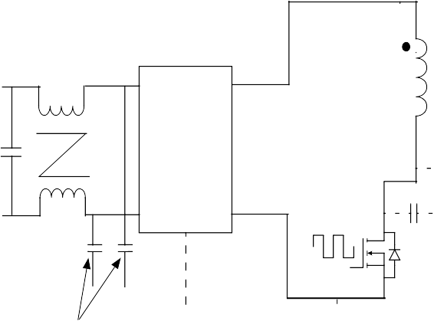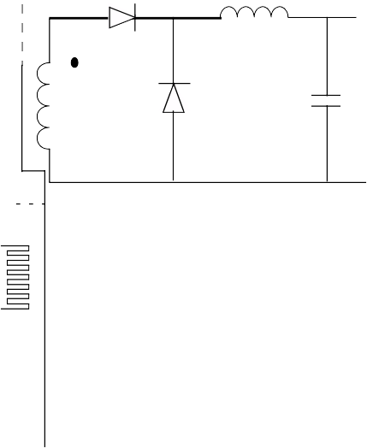

X-capacitor

Diode Bridge

CP2

CY1 CY2

CP1

Y-capacitor

CP5

CP3

# SUMMARY

The appropriate SMPS topology can be selected based on input voltage, output power, and output current (see Table 4).

The selection of topology may differ to meet some of the specific requirements of the power supply including cost, size and personal experience of the designer.

### TABLE 4: SMPS TOPOLOGY SELECTION GUIDELINES

|  |  |  |
| --- | --- | --- |
| **Input voltage** | **Output power** | **Preferred Topology** |
| Universal input (90-264) VAC | Po < 150 watt, Load current < 10A | Flyback, Forward |
| Universal input (90-264) VAC | Po < 150 watt, Load current > 10A | Forward |
| Universal input (90-264) VAC | 150 watt < Po > 350 | Two-Switch Forward, Half-Bridge, Push-Pull |
| Universal input (90-264) VAC | Po < 500 watt | Half-Bridge, Push-Pull |
| Vin > 350 VDC | Po < 750 watt | Half-Bridge |
| Vin< 200 VDC | Po < 500 watt | Push-Pull |
| Vin > 350 VDC | 500 < Po > 1000 watt | Full-Bridge |
| Vin > 350 VDC | Po > 1000 watt | ZVT Full-Bridge |
| Vin > 350 VDC | Po > 2000 watt | More than one ZVT full-bridge in parallel, interleaved with more than one ZVT full-bridge |

**APPENDIX A: GLOSSARY**

**Bipolar Junction Transistor (BJT)**

A BJT is a three-terminal device constructed of doped semiconductor material and may be used in amplifying or switching applications.

**Boost Converter**

A basic SMPS topology in which energy is stored in a inductor when a switch is ON, and is transferred to the output when the switch is OFF. It converts an unregulated input voltage to a regulated output voltage higher than the input.

## Buck Converter

A basic SMPS topology in which a series switch chops the input voltage and applies the pulses to an averaging LC filter, which produces a lower output voltage than the input.

## Constant Output Voltage

A mode of operation when output voltage is regulated regardless of any other parameter changes in the system.

## Current Mode Control

A control method which is using a dual loop circuit to adjust the PWM operation.

## Electromagnetic Interference (EMI)

Unwanted energy, in the form of electrical noise generated from the SMPS, which may be conducted or radiated.

## Faraday Shield

An electrostatic shield between input and output windings of a transformer. This is used to reduce primary to secondary coupling capacitance, which in turn will reduce output common mode noise.

## Feed Forward

A term describing a system that reacts to changes in its environment, usually to maintain some desired state of the system. Also, it is a system that exhibits feed-forward behavior that responds to a measured disturbance in a predefined way, in contrast with a feedback system.

## Flyback Converter (FBT)

An isolated Buck-Boost SMPS topology in which, during the first period of a switching cycle, the energy is stored in a magnetizing inductance of the transformer. Then, during the second period, this energy is transferred to a secondary winding of the same half-bridge resonant converter where the load is connected in series with the resonant tank capacitor, C, and into the load.

## Forward Converter

A Buck-derived SMPS topology in which energy is transferred to the secondary of a transformer winding and into the load, when the switching transistor is ON.

## Full-Bridge Converter

An SMPS topology in which four switches are connected in a bridge configuration to drive the primary of a transformer. This is also known as an H-Bridge Converter.

## H-Bridge Converter

See Full-Bridge Converter.

## Half-Bridge Converter

A SMPS topology similar to a full-bridge converter in which only two switches are used. The other two are replaced by capacitors.

## Half-Bridge LLC Resonant Converter

A SMPS half-bridge topology where the series resonant tank consisting of the inductor, L, and the capacitor, C, which is used to generate another resonant frequency with transformer magnetizing inductance.

## Half-Bridge Resonant Converter

A half-bridge converter using an LC resonant tank to reduce the switching losses in the MOSFET.

## H-Bridge Phase-Shift ZVT Converter

A full-bridge converter using the phase-shift ZVS technique is known as an H-Bridge Phase-Shift ZVT topology. In this topology, the parasitic output capacitor of the MOSFETs and the leakage inductance of the switching transformer are used as a resonant tank circuit to achieve zero voltage across the MOSFET at the turn-on transition.

## LLC Resonant Converter

A full-bridge converter with an LC resonant tank, which is used to reduce switching losses and the phase shift between the two leg gate pulse defined in the output power flow.

## Parallel Resonant Converter (PRC)

A half-bridge resonant converter where the load is connected in parallel with the resonant tank capacitor, C.

## Power Diode

A power diode is a unidirectional semiconductor switch, which has only one PN junction. A power diode is able to carry a large amount of current and typically is able to support a large reverse-bias voltage in the OFF state.

## Power Factor Correction (PFC)

PFC is a technique of counteracting the undesirable effects of electric loads that create a power factor that is less than 1.

## Push-Pull Converter

An SMPS topology which is using usually a center-tap transformer and two switches that are driven ON and OFF alternately.

## Series Resonant Converter (SRC)

A half-bridge resonant converter where the load is connected in series with the resonant tank capacitor, C.

## Snubber

A component or a circuit, active or passive, dissipative or regenerative used in a SMPS to reduce components stress by limiting peak voltage or current, ΔV/Δt, ΔI/Δt.

## Switch Mode Power Supply (SMPS)

A power supply technology in which a switching device, along with a passive component, is used to process the power flow.

## Total Harmonic Distortion (THD)

The total harmonic distortion or THD, of a signal is a measurement of the harmonic distortion present and is defined as the ratio of the sum of the powers of all harmonic components to the power of the fundamental.

## Two-Switch Forward Converter

Used in series with the transformer primary to reduce the reverse blocking voltage of the switch.

## Voltage Mode Control

A control method that uses a single loop to control the output.

### NOTES:

**Note the following details of the code protection feature on Microchip devices:**

* + Microchip products meet the specification contained in their particular Microchip Data Sheet.
  + Microchip believes that its family of products is one of the most secure families of its kind on the market today, when used in the intended manner and under normal conditions.
  + There are dishonest and possibly illegal methods used to breach the code protection feature. All of these methods, to our knowledge, require using the Microchip products in a manner outside the operating specifications contained in Microchip’s Data Sheets. Most likely, the person doing so is engaged in theft of intellectual property.
  + Microchip is willing to work with the customer who is concerned about the integrity of their code.
  + Neither Microchip nor any other semiconductor manufacturer can guarantee the security of their code. Code protection does not mean that we are guaranteeing the product as “unbreakable.”

Code protection is constantly evolving. We at Microchip are committed to continuously improving the code protection features of our products. Attempts to break Microchip’s code protection feature may be a violation of the Digital Millennium Copyright Act. If such acts allow unauthorized access to your software or other copyrighted work, you may have a right to sue for relief under that Act.

Information contained in this publication regarding device applications and the like is provided only for your convenience and may be superseded by updates. It is your responsibility to ensure that your application meets with your specifications. MICROCHIP MAKES NO REPRESENTATIONS OR WARRANTIES OF ANY KIND WHETHER EXPRESS OR IMPLIED, WRITTEN OR ORAL, STATUTORY OR OTHERWISE, RELATED TO THE INFORMATION, INCLUDING BUT NOT LIMITED TO ITS CONDITION, QUALITY, PERFORMANCE, MERCHANTABILITY OR

FITNESS FOR PURPOSE**.** Microchip disclaims all liability arising from this information and its use. Use of Microchip devices in life support and/or safety applications is entirely at the buyer’s risk, and the buyer agrees to defend, indemnify and hold harmless Microchip from any and all damages, claims, suits, or expenses resulting from such use. No licenses are conveyed, implicitly or otherwise, under any Microchip intellectual property rights.

**Trademarks**

The Microchip name and logo, the Microchip logo, Accuron, dsPIC, KEELOQ, KEELOQ logo, microID, MPLAB, PIC,

PICmicro, PICSTART, PRO MATE, rfPIC and SmartShunt

are registered trademarks of Microchip Technology Incorporated in the U.S.A. and other countries.

AmpLab, FilterLab, Linear Active Thermistor, Migratable Memory, MXDEV, MXLAB, SEEVAL, SmartSensor and The Embedded Control Solutions Company are registered trademarks of Microchip Technology Incorporated in the U.S.A.

Analog-for-the-Digital Age, Application Maestro, CodeGuard, dsPICDEM, dsPICDEM.net, dsPICworks, dsSPEAK, ECAN, ECONOMONITOR, FanSense, FlexROM, fuzzyLAB,

In-Circuit Serial Programming, ICSP, ICEPIC, Mindi, MiWi,

MPASM, MPLAB Certified logo, MPLIB, MPLINK, PICkit, PICDEM, PICDEM.net, PICLAB, PICtail, PowerCal, PowerInfo, PowerMate, PowerTool, REAL ICE, rfLAB, Select Mode, Smart Serial, SmartTel, Total Endurance, UNI/O, WiperLock and ZENA are trademarks of Microchip Technology Incorporated in the U.S.A. and other countries.

SQTP is a service mark of Microchip Technology Incorporated in the U.S.A.

All other trademarks mentioned herein are property of their respective companies.

© 2007, Microchip Technology Incorporated, Printed in the U.S.A., All Rights Reserved.

Printed on recycled paper.



*Microchip received ISO/TS-16949:2002 certification for its worldwide headquarters, design and wafer fabrication facilities in Chandler and Tempe, Arizona; Gresham, Oregon and design centers in California and India. The Company’s quality system processes and procedures are for its PIC® MCUs and dsPIC® DSCs, KEELOQ® code hopping devices, Serial EEPROMs, microperipherals, nonvolatile memory and analog products. In addition, Microchip’s quality system for the design and manufacture of development systems is ISO 9001:2000 certified.*

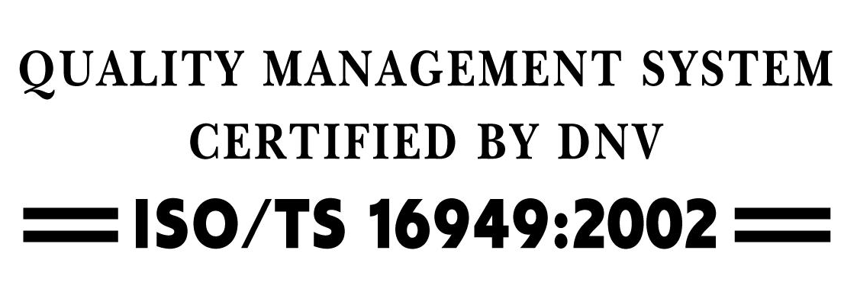

**WORLDWIDE SALES AND SERVICE**

### AMERICAS

**Corporate Office**

2355 West Chandler Blvd.

Chandler, AZ 85224-6199

Tel: 480-792-7200

Fax: 480-792-7277

Technical Support: [http://support.microchip.com](http://support.microchip.com/) Web Address: [www.microchip.com](http://www.microchip.com/)

**Atlanta**

Duluth, GA

Tel: 678-957-9614

Fax: 678-957-1455

**Boston** Westborough, MA Tel: 774-760-0087

Fax: 774-760-0088

**Chicago**

Itasca, IL

Tel: 630-285-0071

Fax: 630-285-0075

**Dallas**

Addison, TX

Tel: 972-818-7423

Fax: 972-818-2924

**Detroit**

Farmington Hills, MI

Tel: 248-538-2250

Fax: 248-538-2260

**Kokomo**

Kokomo, IN

Tel: 765-864-8360

Fax: 765-864-8387

**Los Angeles** Mission Viejo, CA Tel: 949-462-9523

Fax: 949-462-9608

**Santa Clara** Santa Clara, CA Tel: 408-961-6444

Fax: 408-961-6445

**Toronto** Mississauga, Ontario, Canada

Tel: 905-673-0699

Fax: 905-673-6509

### ASIA/PACIFIC

**Asia Pacific Office** Suites 3707-14, 37th Floor Tower 6, The Gateway Harbour City, Kowloon Hong Kong

Tel: 852-2401-1200

Fax: 852-2401-3431

**Australia - Sydney**

Tel: 61-2-9868-6733

Fax: 61-2-9868-6755

**China - Beijing**

Tel: 86-10-8528-2100

Fax: 86-10-8528-2104

**China - Chengdu**

Tel: 86-28-8665-5511

Fax: 86-28-8665-7889

**China - Fuzhou**

Tel: 86-591-8750-3506

Fax: 86-591-8750-3521

**China - Hong Kong SAR**

Tel: 852-2401-1200

Fax: 852-2401-3431

**China - Nanjing**

Tel: 86-25-8473-2460

Fax: 86-25-8473-2470

**China - Qingdao**

Tel: 86-532-8502-7355

Fax: 86-532-8502-7205

**China - Shanghai**

Tel: 86-21-5407-5533

Fax: 86-21-5407-5066

**China - Shenyang**

Tel: 86-24-2334-2829

Fax: 86-24-2334-2393

**China - Shenzhen**

Tel: 86-755-8203-2660

Fax: 86-755-8203-1760

**China - Shunde**

Tel: 86-757-2839-5507

Fax: 86-757-2839-5571

**China - Wuhan**

Tel: 86-27-5980-5300

Fax: 86-27-5980-5118

**China - Xian**

Tel: 86-29-8833-7252

Fax: 86-29-8833-7256

### ASIA/PACIFIC

**India - Bangalore**

Tel: 91-80-4182-8400

Fax: 91-80-4182-8422

**India - New Delhi**

Tel: 91-11-4160-8631

Fax: 91-11-4160-8632

**India - Pune**

Tel: 91-20-2566-1512

Fax: 91-20-2566-1513

**Japan - Yokohama**

Tel: 81-45-471- 6166

Fax: 81-45-471-6122

**Korea - Daegu**

Tel: 82-53-744-4301

Fax: 82-53-744-4302

**Korea - Seoul**

Tel: 82-2-554-7200

Fax: 82-2-558-5932 or

82-2-558-5934

**Malaysia - Kuala Lumpur**

Tel: 60-3-6201-9857

Fax: 60-3-6201-9859

**Malaysia - Penang**

Tel: 60-4-646-8870

Fax: 60-4-646-5086

**Philippines - Manila**

Tel: 63-2-634-9065

Fax: 63-2-634-9069

**Singapore**

Tel: 65-6334-8870

Fax: 65-6334-8850

**Taiwan - Hsin Chu**

Tel: 886-3-572-9526

Fax: 886-3-572-6459

**Taiwan - Kaohsiung**

Tel: 886-7-536-4818

Fax: 886-7-536-4803

**Taiwan - Taipei**

Tel: 886-2-2500-6610

Fax: 886-2-2508-0102

**Thailand - Bangkok**

Tel: 66-2-694-1351

Fax: 66-2-694-1350

### EUROPE

**Austria - Wels**

Tel: 43-7242-2244-39

Fax: 43-7242-2244-393

**Denmark - Copenhagen**

Tel: 45-4450-2828

Fax: 45-4485-2829

**France - Paris**

Tel: 33-1-69-53-63-20

Fax: 33-1-69-30-90-79

**Germany - Munich**

Tel: 49-89-627-144-0

Fax: 49-89-627-144-44

**Italy - Milan**

Tel: 39-0331-742611

Fax: 39-0331-466781

**Netherlands - Drunen**

Tel: 31-416-690399

Fax: 31-416-690340

**Spain - Madrid**

Tel: 34-91-708-08-90

Fax: 34-91-708-08-91

**UK - Wokingham**

Tel: 44-118-921-5869

Fax: 44-118-921-5820

09/10/07